Ms Merry’s 4th Class 11/5/2020
Week 6 – It’s GET Arty Week!

Hi all! Great to keep hearing from people through email. Try to correct your mental maths either as you go along each day or at the end of the week. If you are stuck on the problem-solving and can’t figure out where the answer came from, email me and I will try to explain. 😁
Remember that the activities highlighted in red is the work I want you to send me on the Friday of that week. Here is it for this week:
WORK TO SEND ON FRIDAY TO MY EMAIL
jmerry@scoilchaitrionasns.ie
- Your play you have written based on your chosen tale from Aesop’s Fables. Remember to read over it to check for spellings and punctuation before sending it!

- The drawing from observation that you have done.

- Your score for your spelling test on Friday.

Day 1
- Mental Maths corrections: Make sure you have corrected your work up as far as week 28 that you have done.

https://www.newwavementalmaths.ie/my-login/
Log in: JMerry@scoilchaitrionasns.ie and the password is Mental1.

- Mental Maths: Week 29 Mon and Problem Solving
- Spelling:
- Continue with the basic spellings list that I sent you using the activities below:

- Write them in different colours in your copy
- Write them in the air
- Write them on someone’s back (with your finger!)
- Type them out each five times each
- Say the letters in the word out loud quickly three times
- Write them into a silly sentence
- Then, see if you can remember them by writing them again without looking at them.
- If you have finished all the spellings on that list use this website to find some new spellings:

http://www.ictgames.com/mobilePage/spookySpellings/index.html

It’s a game with levelled spellings. Start with Year 3 & 4, Level 6 and press Go. You get to look at it and then try to spell without looking. If that’s too hard, try going down a level and if it’s too easy go up levels or even try the spellings for Year 5 and 6.

Day 2
- Mental Maths: Week 29 Tue and Problem Solving
- Silent reading: 30 minutes (I will be asking you to write a book review next week so start deciding which book you will use to do this)
- Spelling: As above

- Visual Art: Check out this website. http://www.iamanartist.ie/drawing/ Go to the video that is entitled ‘Drawing from Observation’ and watch it to the end. (You will have to watch it in small, as it will not stay in full screen).

- Have a look at these drawings. ‘Drawing from observation’ is drawing what you see, it means looking really closely at what you’re drawing.

Think:
What are the objects that the artist has drawn in each sketch?
What kind of utensils have they used to draw them – pencil? Charcoal? Crayon? Pastel?
What kind of lines have they drawn – straight? Curved? Wavy?

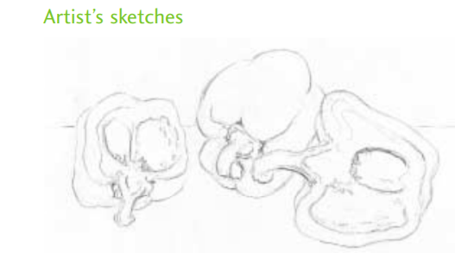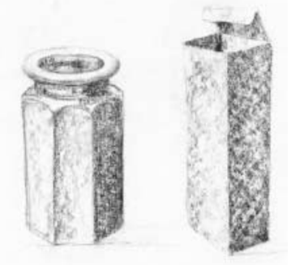
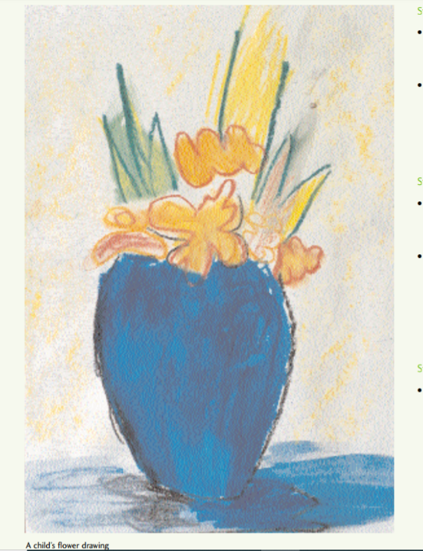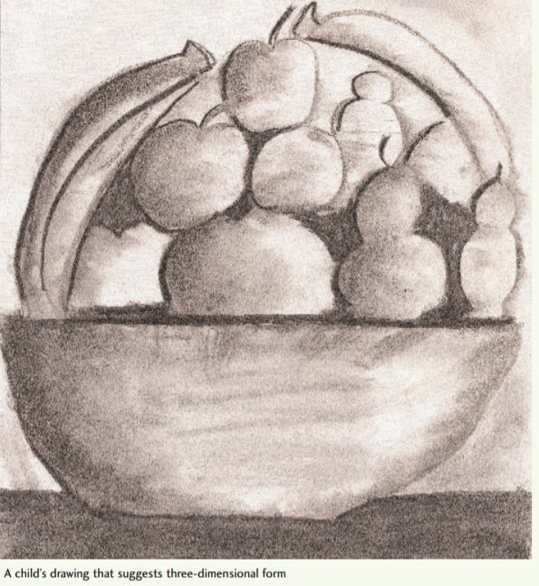
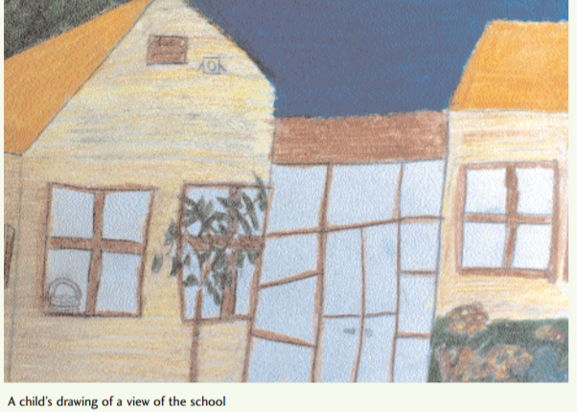
- Drawing from observation – Now it’s your turn! The more you look, the more you see! Find any kind of paper or cardboard, pencils, crayons etc.
- Choose something in your house or outside in the garden. Look at kitchenware, toys, clothes, flowers, fruit, vegetables, your pencil case and the objects from it, some things that are on your bedside dresser. Try to pick some things that are related in some way e.g. some different toys go together, some objects on the breakfast table go together, some plants in pots go together.
- Have a go at drawing them now!

If you want a Maths challenge!

- Maths: Choose a problem from nrich on 3D shapes https://nrich.maths.org/public/topic.php?ct=0&cl=2&dl%5B0%5D=1&dl5B1%5D=1&dl%5B2%5D=1&group_id=10&cldcmpid=&code=114#results

Day 3
- Mental Maths: Week 29 Wed and Problem Solving
- Silent reading: 30 minutes (I will be asking you to write a book review next week so start deciding which book you will use to do this)
- Spelling: As above

SPHE/Music - singing:

Check out this rap about staying safe online. Play it three times. Have a go at learning it! Try to sing the chorus to start.

https://vimeo.com/119144265

Here are the words!

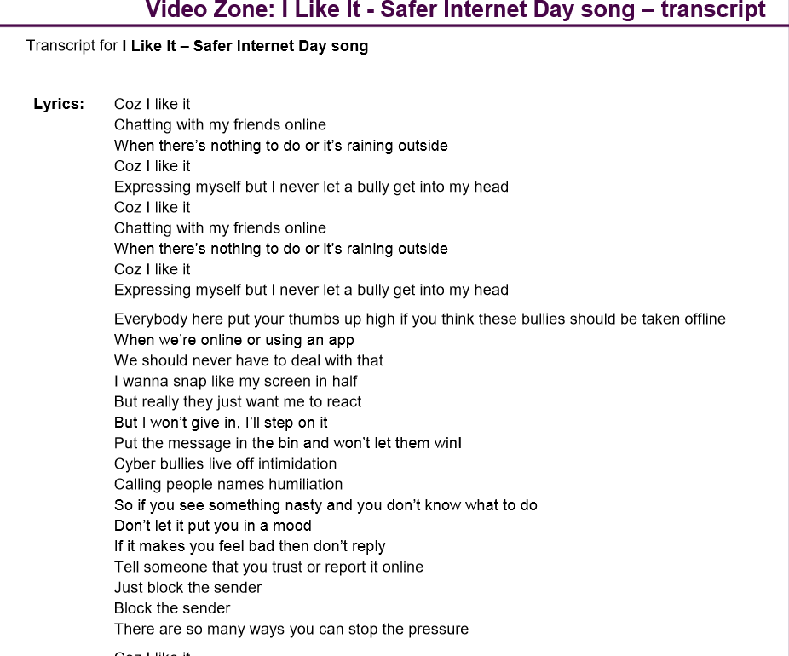

- Music - composing: Have a go at making up a song or rap about something you love or do! You can even change the lyrics of a famous song or nursery rhyme. Here are some ideas to help you:

http://www.readwritethink.org/files/resources/lesson_images/lesson1026/lyrics.pdf

Maybe you could perform it, record it or write down the lyrics and email it to me?!

Day 4
- Mental Maths: Week 28 Thurs and Problem Solving
- Silent reading: 30 minutes
- Spelling: As above
- SPHE/Music: Play the rap about cyber-bullying and see if you can learn some more of it.

- Drama: Here are four of Aesop's Fables. These are stories which teach us a lesson. Watch the short videos on each of the fables below and choose one. Write it out like a play – it will look something like this, if you were writing a play for the Three Little Pigs story, for example. Remember to include the moral of the story at the end (the life lesson – what the author is trying to teach us through the story).

The Three Little Pigs
by Mary Brown
Cast of Characters
Mother Pig
First Little Pig
Second Little Pig
Third Little Pig
Big Bad Wolf
Scene One
(The forest, inside Mother Pig's house. Mother Pig has called her three
children together. They sit listening to her.)

NARRATOR
One day, Mother Pig called her three children together. She wanted to tell them it was time they left home.
MOTHER PIG
Now, boys, you know you're grown up now. It's time you set out on your own. And you'll have to make your own houses.

(Two of the Little Pigs really don't want to go.)

NARRATOR

Two of the Little Pigs really didn't want to go.
FIRST LITTLE PIG
We don't wanna!
SECOND LITTLE PIG
Awe, Mom, do we have to?
NARRATOR
But the Third Little Pig understood.
THIRD LITTLE PIG
Mam's right, guys. Let's go.

(The Three Little Pigs leave the house forever.)

Scene Two
(etc.)

FIRST, WATCH THIS INTRODUCTION TO FABLES
https://www.youtube.com/watch?v=ruX6oQeLC3M&feature=emb_rel_end

WATCH ALL OF THESE FABLES FIRST. AFTER THAT, CHOOSE ONE OF THEM FOR YOUR PLAY AND GET SCRIPTING!!
- The Hare and the Tortoise
https://www.youtube.com/watch?v=pjokVI0LJzw

- The Boy who Cried Wolf
https://www.youtube.com/watch?v=c2K1izu699c

- The Ants and the Grasshopper

https://www.youtube.com/watch?v=YT5DnTKm3YE&list=PLV3Gd8vEgOrjwNozO76QH0BR32vDy_hId&index=13

Day 5
- Mental Maths: Week 28 Fri review and Problem Solving
- Silent reading: 30 minutes
- Spelling: Revise all the spellings you did this week by using look, cover, say, write and check. Now ask someone at home to give you a test on these spellings. Good luck!

- Drama:
- Yesterday, you chose one of Aesop’s fables and wrote the play for it. Today, maybe have a go at acting it out! Maybe you could ask your siblings (or parents!) to join in. You will have to decide who is going to be each character and the narrator.
- If you and some others are acting it out remember to try and use facial expressions, an expressive voice, hand movements and even props to make it look realistic!
- Another alternative would be to use your toys to act it out, with you doing the voices.
- If you would like to add visual art to this and have marla/play dough/plasticine/clay at home, you could make the characters with them and act out using your 3D characters.
- You could also simply draw the characters on paper and use these and do the voices yourself.
- You could video this and email it to me, if you’d like to show me what you came up with!

EXTRA CREATIVE CHALLENGE - optional
- Create your own drama! Write a script and act it out. Ideas could be a haunted house, a sleepover, an Aesop’s fable or even changing a story like Cinderella! Again, I would love for you to email me anything you do.

See below for MATHS CORRECTIONS from last week.

Answers for maths corrections from Week 5

Maths Challenge (optional): 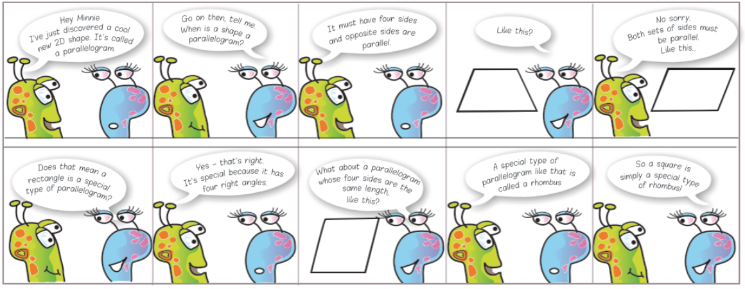
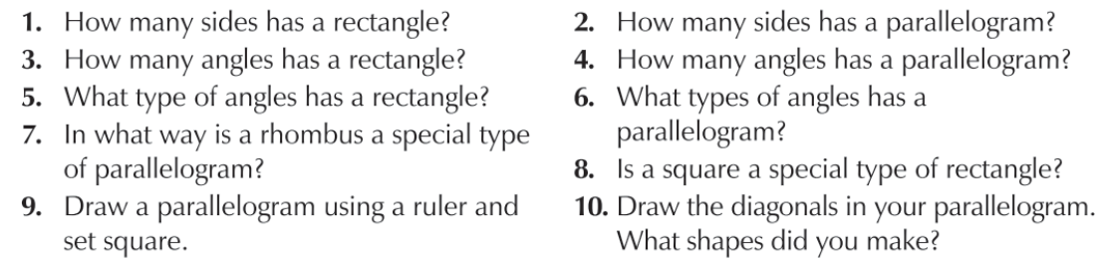

Maths Challenge Answers

1 A rectangle has 4 sides.
2. A parallelogram has 4 sides.
3. A rectangle has 4 angles.
5. A parallelogram has 4 angles.
6. A parallelogram has two obtuse and two acute angles.
7. A parallelogram is a shape with four sides and both sets of opposite sides are parallel. A rhombus is a special type of parallelogram because it is a shape with four sides, it has both sets of sides parallel AND the four sides are the same length.
8. No, a square is a special type of rhombus. It’s special because all the angles in a square are right angles.
10. Triangles.
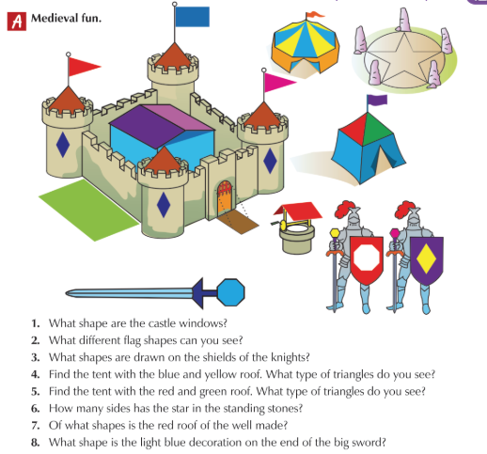

Medieval Fun Answers
1. The castle windows are the shape of a rhombus.
2. The flags are shaped as isosceles triangles and a rectangle.
3. On the left shield is an octagon and on the right shield is a rhombus.
4. The triangles on the roof of the blue and yellow tent are isosceles triangles.
5. The triangles on the roof of the green and red tent are equilateral.
6. The start has ten sides (5 points, and each point has two sides so 2 times 5 is ten.)
7. The red roof of the well is made from two rectangles.
8. The decoration is an octagon.

