Ms Merry’s 4th Class 2/6/2020
Week 9

Hi all! Great to keep hearing from people through email. Try to correct your mental maths either as you go along each day or at the end of the week. If you are stuck on the problem-solving and can’t figure out where the answer came from, email me and I will try to explain. 😁
Remember that the activities highlighted in red, is the work I want you to send me on the Friday of that week. Here is it for this week:
WORK TO SEND ON FRIDAY TO MY EMAIL
jmerry@scoilchaitrionasns.ie

- Your score for your spelling test that you will be doing on Friday from the list below.

- Five more sentences from Duolingo you will have learned this week.

- Your answers to the question from Summer in Ireland and the missing words from the European Landmarks.

Day 1
- Mental Maths corrections: Make sure you have corrected your work up as far as you have done.

https://www.newwavementalmaths.ie/my-login/

Log in: JMerry@scoilchaitrionasns.ie and the password is Mental1.

- Mental Maths: Week 31 Mon and Problem Solving

- Irish: Go online to https://www.duolingo.com/learn Spend ten minutes or so on the exercises.

- Spelling writing: These are your spellings for this week in the box below. If you don’t know what a word means, look up this online dictionary https://kids.wordsmyth.net/we/ (you put the word you are looking for in the box on the left-hand side).

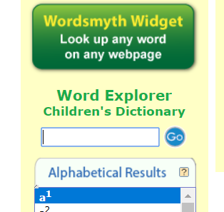

- Spelling learning: Look at the first 6 spellings – say the letters of each, picture in your head, write them and check your answer.
- Unscramble the words.
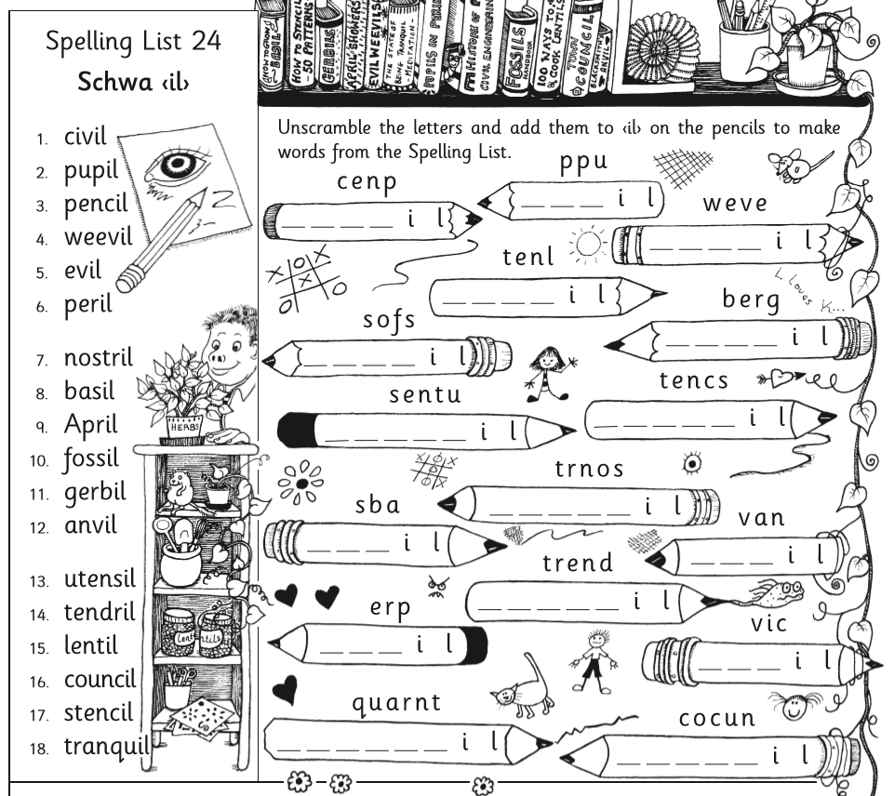
- English Reading: If you had to write a piece about Summer in Ireland, what would you talk about in your writing piece? Write down ten key words that you might include.
- Predicting: Tomorrow you will read a text about Summer in Ireland. But first read the questions that will come after it. Can you predict what the answers will be? Read each question and, in your head, think about what a sensible answer to it would be.
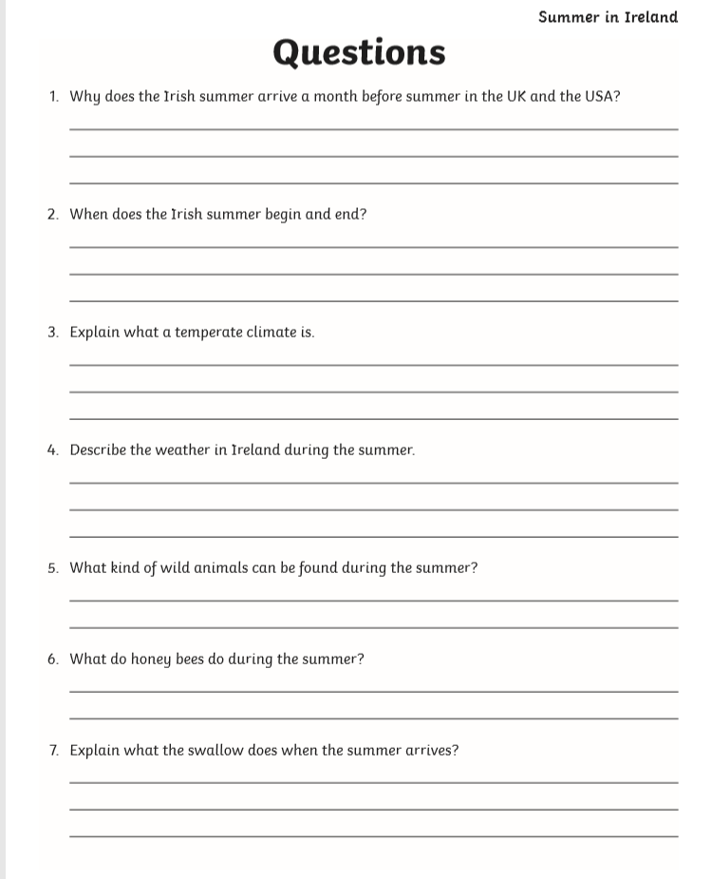

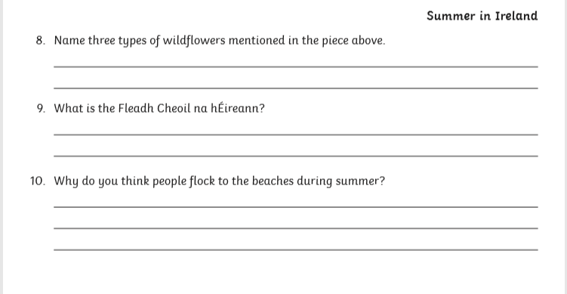
Day 2
- Mental Maths: Week 31 Tue and Problem Solving
- Silent reading: 30 minutes of your own book OR read the first chapter of JK Rowling’s new book, ‘The Ickabog’ here! https://www.theickabog.com/king-fred-the-fearless/
- Spelling: As above. Learn how to spell the next 6 spellings from the list above.
- Irish: Go online to https://www.duolingo.com/learn Spend ten minutes or so on the exercises.
- English Reading: Now read the piece below. First read it silently, then read it aloud for someone at home.
- Answer time! Now, go back and answer the questions from yesterday. Make sure to check the text (this is not a memory test!) to make sure the information you are writing is correct. You can either print off the sheet and write on it, or alternatively write the answers in your copy. Read back over it and check your answers for capital letters, full stops and spellings.

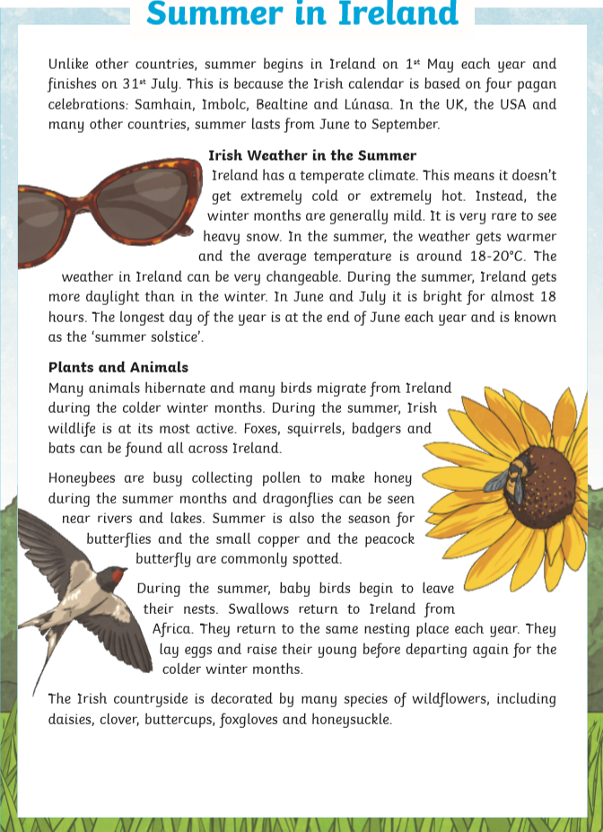
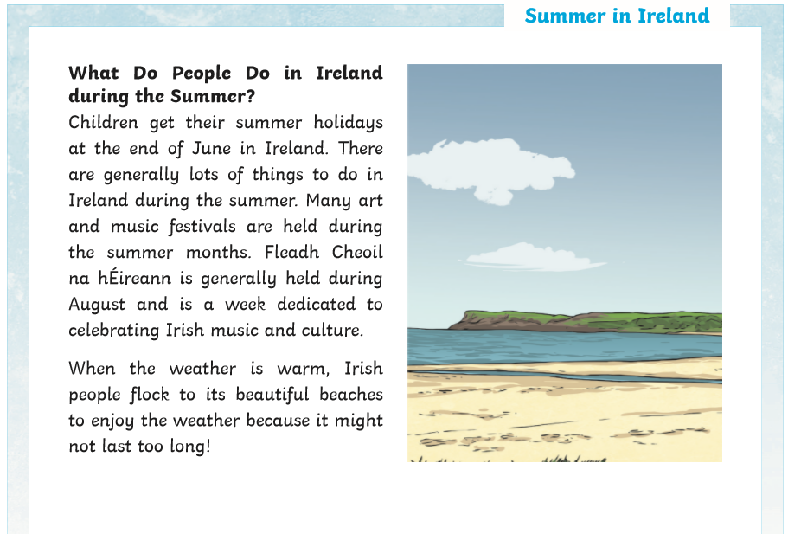

Day 3
- Mental Maths: Week 31 Wed and Problem Solving
- Silent reading: 30 minutes of your own book OR read the second chapter of JK Rowling’s new book, ‘The Ickabog’ here! https://www.theickabog.com/the-ickabog/
- Spelling: As above, next 6.
- Irish: Go online to https://www.duolingo.com/learn Spend ten minutes or so on the exercises.
- English/Geography: Fill in the missing words below. Remember to read over the sentence after you put in what you think the missing word is. Read it out loud and see does it sound correct!

Day 4
- Mental Maths: Week 31 Thurs and Problem Solving
- Spelling: Ask someone at home to give you a test on these spellings. Good luck
- Silent reading: 30 minutes of your own book OR read the third chapter of JK Rowling’s new book, ‘The Ickabog’ here! https://www.theickabog.com/death-of-a-seamstress/
- Irish: Go online to https://www.duolingo.com/learn Spend ten minutes or so on the exercises.
- English/SESE: Fill in the gaps with the most suitable word.

