Ms Merry’s 4th Class 28/3/2020

Work for Weeks 3 and 4

Pen license: All girls in my class can now assume that they have their pen license and may start to write in pen - congratulations! 😁

READ THIS!
Try to do the basics every day – that means your Mental Maths, Read at Home, tables practice and silent reading.
If you have access to the internet (and permission to go on it from your parent/guardian) try and have a go at the other activities!

Day 1
- Mental Maths corrections: Make sure you have corrected your work from the past two weeks.

https://www.newwavementalmaths.ie/my-login/
Log in: JMerry@scoilchaitrionasns.ie and the password is Mental1.

- Mental Maths: Week 26 Mon and Problem Solving
- Read at Home corrections: Use the answers below to correct all your questions from Day 1 to 5.

Read at Home Answers
Day 1: The Letter - Page 120
- Jane is writing to her best friend Laura.
- Jane has moved to a new house and a new school. She has a new uniform, different books, a different teacher and new friends.
- The class pet is a lizard. It is called Monty and he stays in a glass tank at the back of the classroom.
- Mr Kelly seems to like history and geography best. He loves to tell crazy history stories and host geography quizzes.
- Hazel and Rachel like to sing and chat. They also like to dance as they go to dance class after school.

Day 2: Sputnik - Page 119
- Sputnik 1 was launched on the 4th of October 1957.
- The Soviet Union, which is now called Russia, launched this satellite.
- The Sputnik 1 tumbled back to Earth, burning up as it shot back through the air.
- The global positioning system (GPS) works by using signals from satellites to figure out where the person is and where they need to go.
- Two other uses of satellites include providing television stations all around the world and taking pictures of Earth to help weather forecasters to predict the weather. (Other possible answer: People can call their friends and family on the other side of the world because of satellites.)

Day 3: Chocolate - Page 118
- The cocoa bean was first discovered more than 4000 years ago in the Amazon rainforest of South America.
- The Mayan people passed on the secret of chocolate to the Aztec people.
- In 1519, Spain invaded the empire of the Aztecs in modern-day Mexico.
- Sugar was first added to chocolate in Spain.
- The first proper eating chocolate was made in Britain in 1830.
Day 4: - Txt U L8r Page 115
- The name of the poem is ‘Txt U L8r’.
- Aislinn O’Loughlin wrote the poem.
- Text talk/spelling is the kind of spelling used – where you use abbreviations and drop some vowels.
- Yes, I could read it once I had worked out that many of the vowels had been dropped.
- Some older people who perhaps are used to writing text messages would be able to read it. I think it would be tricky to read for some older people who haven’t seen this kind of writing before.
- Abbreviations are short forms of words. This sentence means that the letters ‘abrvi8ns’ is the shorthand way of writing the word ‘abbreviation’.
- The poem is confusing because it takes a bit of time to work out what the words actually are because they aren’t written using normal spelling.
- Text spelling is handy sometimes when I want to write something quickly. However, sometimes it can be confusing if the person writing it has abbreviated it so much that you can’t actually figure out what the word is!

Day 5: Valentina Tereshkova - Page 114
- On the 16th June 1963, Valentina Tereshkova became the first woman to go into outer space.
- Her first job was working in a local textile (cloth or fabric) factory.
- Five women were selected for the space program – Valentina and four others.
- In Russia, astronauts are called cosmonauts.
- Vostok 6 was the name of the space rocket.

__________________________________________________

- Writing and Grammar: Conjunctions are connecting words. Do exercises A and B.

(Hint: In A, read all of the sentences first before you choose which missing word goes where. Do the easy ones first and come back last to the ones you’re not totally sure about.)

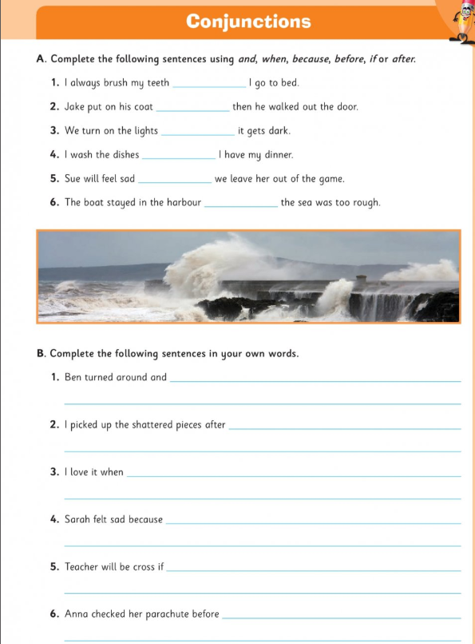

- Tables: Spend 10 minutes on either www.multiplication.com or https://www.topmarks.co.uk/maths-games/7-11-years/multiplication-and-division. Work on the Division questions.
- Spelling:
- Go to the very last pages of this document where you will find some spelling lists.
- Start with Grade 4 words (but if you think there are words in Grade 2 or 3 that you need to learn, then start there instead). Have someone in your house test you until you find five that you made a mistake in and need to learn.

Do these activities to help you learn the words:

- Write them in different colours in your copy
- Write them in the air
- Write them on someone’s back (with your finger!)
- Type them out each five times each
- Say the letters in the word out loud quickly three times
- Write them into a silly sentence
- Then, see if you can remember them by writing them again without looking at them.

Already know all of Grade 4? Go on to Grade 5 words.
For those really tricky ones try the SOS method. You may need help from an adult or older sibling:
https://localoffer.haltonchildrenstrust.co.uk/wp-content/uploads/2015/12/SOS-Spelling-Method.pdf

Day 2
- Mental Maths: Week 26 Tue and Problem Solving
- Read at Home: Use the answers below to correct all your questions from Day 6 to 10.
- Silent reading: 30 minutes
- Tables: Spend 10 minutes on either www.multiplication.com, https://www.topmarks.co.uk/maths-games/7-11-years/multiplication-and-division. Work on the Division questions.
- If you want further challenge: Pick a problem from https://nrich.maths.org/primary
- Spelling: Continue with the next five words you found out you didn’t know as described in Day 1.
- Irish: Go online to https://www.duolingo.com/learn Click that you want to learn Irish (it has a picture of the Irish flag). Click the option ‘School’ when they ask you why you are learning this language. Spend ten minutes or so on the exercises.
- Procedural reading activity! You must have an adult supervise you for this – very important!
Have a go at making the flapjacks from page 107 of Read at Home.

Read at Home Answers
Day 6: - Page 113
- The twin girls in the story are called Tara and Laura.
- Identical twins are sisters or brothers that are born at the same time and look very similar or nearly exactly the same as each other.
- Mum mixed them up with each other because they were wearing their school uniforms.
- ‘I wish I could learn to play the guitar!’ was the sentence of Laura’s that Tara finished.
- Granny said she liked being a twin because she said her twin was her best friend and because of this she was never lonely. She said that she felt sorry for people that didn’t have a twin.
Day 7: - Page 112
- The three astronauts on the Apollo 11 mission were Buzz Aldrin, Neil Armstrong and Michael Collins.
- The man in the photograph is Buzz Aldrin.
- Neil Armstrong took the photograph.
- The landing almost didn’t take place because the surface on which the lunar module was about to land was covered with rocks and boulders. If the lunar module had landed on them it could have tipped over on landing. Eventually, they found a clear spot on the surface of the moon on which they could land the craft safely.
- The lunar module was called The Eagle.
Day 8: - Page 110
- The nearest planet to Earth is Venus.
- Venus is closer to the Sun than Earth.
- The dense layers of cloud act like a giant blanket to lock in all the heat from the Sun around the planet.
- The clouds are made of strong acids.
- Scientists study the weather on Venus to learn more about the effect that too much smoke and fumes would have on the atmosphere on Earth. This is called global warming (now called Climate Change or Climate Chaos) and is a current and huge environmental problem for the Earth.
Day 9: - Page 109
- It is a close match because with only two minutes to go both teams are on a score of one goal each.
- Brian tries to score a last-minute goal.
- The star striker has been fouled and has hurt his knee/leg so consequently (because of this) he can’t take the shot.
- Brian feels a ‘tingle of fear’ and is unsure which way to take the shot.
- I think Brian’s team won because he seemed to have lots of ideas about the different ways he could take the shot and chances are that one of them worked!
Day 10: - Page 108
- The pyramid at Chichen Itza is in Mexico.
- The Taj Mahal is made of marble.
- The city of Petra is located on the edge of the Arabian desert.
- The Great Wall of China was built to keep invading tribes out of China.
- The Colosseum was built in Ancient Roman times and used as an arena where cruel fights and games took place for the amusement of the Romans (!).

Day 3
- Mental Maths: Week 26 Wed and Problem Solving
- Read at Home: Do page 106 Silent reading: 30 minutes
- Tables: Spend 10 minutes on either www.multiplication.com or https://www.topmarks.co.uk/maths-games/7-11-years/multiplication-and-division. Work on the Division questions.
- If you want further challenge: Pick a problem from https://nrich.maths.org/primary
- Spelling: Continue with the next five words you found out you didn’t know, as described above.
- Irish: Go online to https://www.duolingo.com/learn Spend ten minutes or so on the exercises.
- English Writing genre / Science:

- We are going to be reading and writing in the explanatory (explanation) genre. This writing genre is used to explain how something works or the processes involved in actions or events. Read the explanatory text called, ‘The Lifecycle of a frog’.

- Highlight all the time conjunction words with a highlighter or pen/pencil. (If you can’t print this document off write these time conjunctions down in your copy.)

- Time conjunctions are words like before, after, then, next, finally, meanwhile
- Look at the checklist for writing a good explanatory text below. Read the text again and tick which ones from the checklist are found in this text.
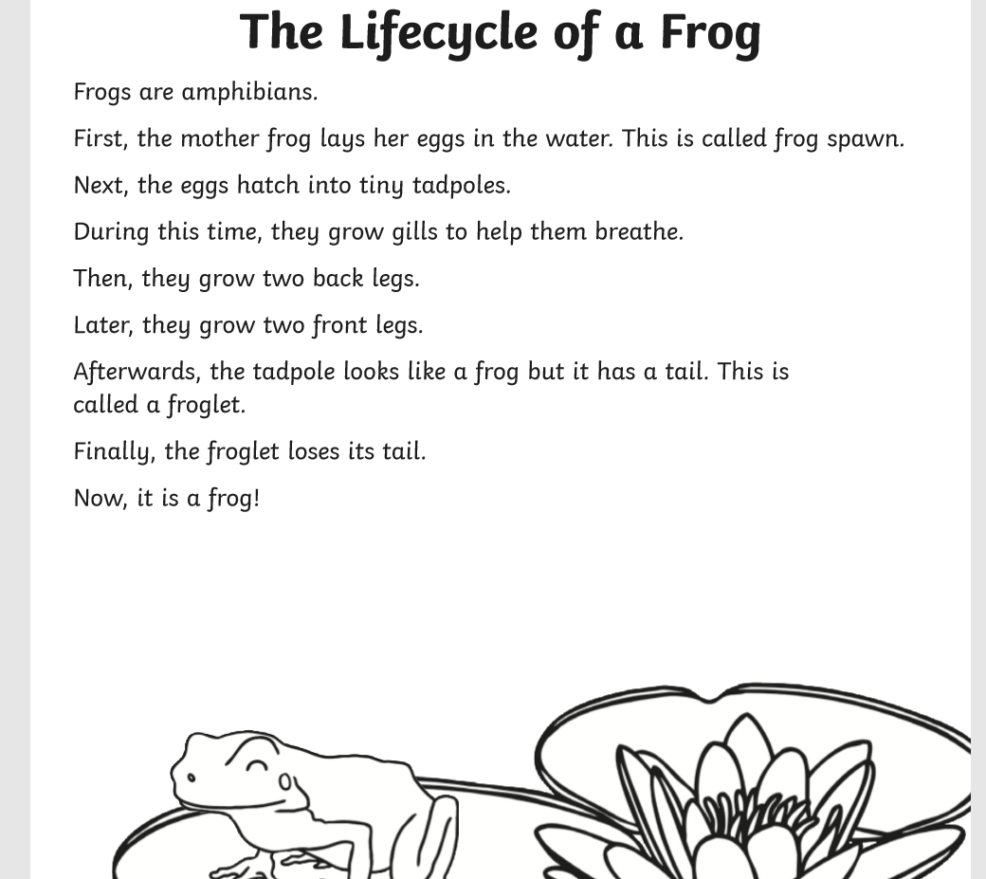

Explanation Texts Checklist | Yes / No?
- Is there a clear title to show what is being explained?
- An opening statement to introduce the process?
- Clear steps to show how or why something occurs?
- The events in order (what came first, second, third and so on)?
- Time conjunctions (e.g. before, after, then, next, finally, meanwhile)?
- Cause and effect conjunctions (e.g. because, so, this causes, therefore, thus, consequently, as a result)?
- Illustrations / diagrams / flow charts to make explanation clearer?

Day 4
- Mental Maths: Week 26 Thurs and Problem Solving
- Read at Home: Do page 105 Silent reading: 30 minutes
- Tables: Spend 10 minutes on either www.multiplication.com or https://www.topmarks.co.uk/maths-games/7-11-years/multiplication-and-division. Work on the Division questions.
- If you want further challenge: Pick a problem from https://nrich.maths.org/primary
- Spelling: Continue with the next five words you found out you didn’t know, as described in Day 1.
- Irish: Go online to https://www.duolingo.com/learn Spend ten minutes or so on the exercises.
- English Writing genre / Science:

- Read the explanatory text called, ‘How do tadpoles grow?’

- Highlight all the time conjunctions.

- Look at the checklist below. Read the text again and tick if all these are in this tadpole text.

- Which of these specialized words goes with which part of the diagram? Frog spawn, adult frog, froglet, tadpole
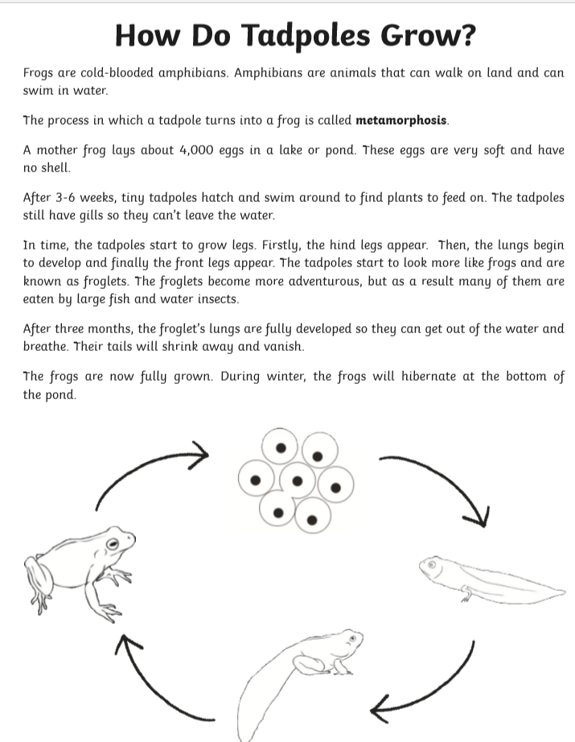
Explanation Texts Checklist | Yes / No?
- Is there a clear title to show what is being explained?
- An opening statement to introduce the process?
- Clear steps to show how or why something occurs?
- The events in order?
- Conjunctions of time (e.g. before, after)?
- Cause and effect conjunctions (e.g. because, so, this causes, therefore, thus, consequently, as a result)?
- Illustrations/diagrams/flow charts to make explanation clearer?

Day 5
- Mental Maths: Week 26 Fri review and Problem Solving
- Read at Home: Do page 104
- Silent reading: 30 minutes
- Tables: Spend 10 minutes on either www.multiplication.com or https://www.topmarks.co.uk/maths-games/7-11-years/multiplication-and-division. Work on the Division questions.
- If you want further challenge: Pick a problem from https://nrich.maths.org/primary
- Spelling: Continue with the next five words you found out you didn’t know, as described in Day 1.
- Irish: Go online to https://www.duolingo.com/learn Spend ten minutes or so on the exercises. Tell someone in your house one of the new phrases you have learned.
- English Writing genre / Geography:
- Read the explanatory text called, ‘The Water Cycle’.

- Can you match up the technical (specialized words we use for a particular subject): precipitation, infiltration, condensation and evaporation with the correct arrows on the diagram (One set of arrows you can only see the top parts of them)?

- Read the text again and tick your checklist to show which of these are found in this particular text.
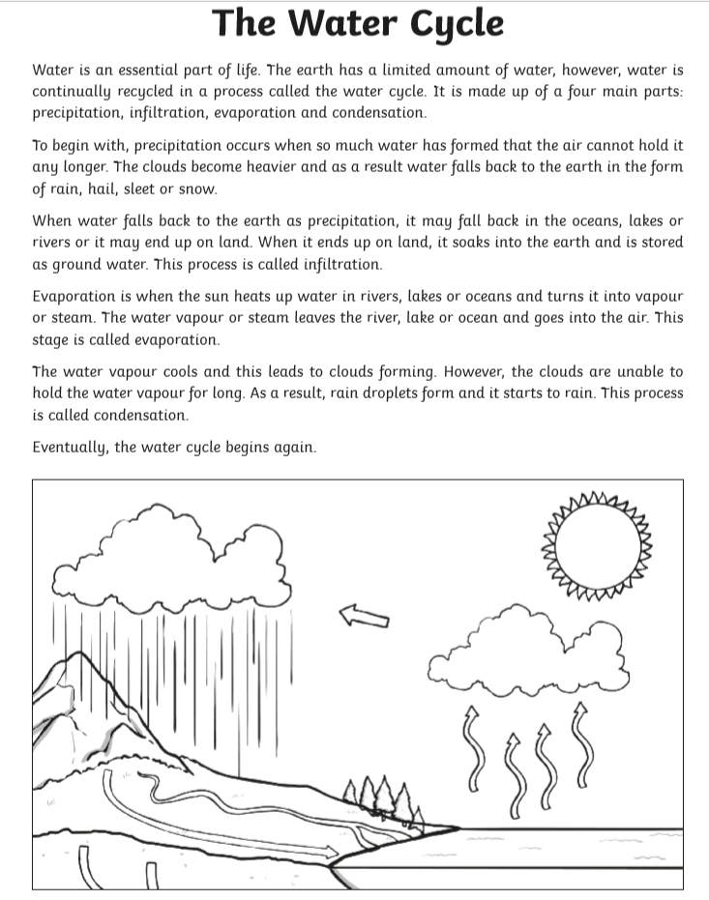
Explanation Texts Checklist  - Is there a clear title to show what is being explained?  - An opening statement to introduce the process?  - Clear steps to show how or why something occurs?  - The events in order?  - Conjunctions of time (e.g. before, after)?  - Cause and effect conjunctions (e.g. because, so, this causes, therefore, thus, consequently)?  - Illustrations/diagrams/flow charts to make explanation clearer? | Yes/No?

Day 6
- Mental Maths: Week 27 Mon and Problem Solving
- Read at Home: Do page 103
- Silent reading: 30 minutes
- Tables: Spend 10 minutes on either www.multiplication.com or https://www.topmarks.co.uk/maths-games/7-11-years/multiplication-and-division. Work on the Division questions.
- If you want further challenge: Pick a problem from https://nrich.maths.org/primary
- Spelling: Continue with the next five words you found out you didn’t know, as described in Day 1.
- Irish: Go online to https://www.duolingo.com/learn Spend ten minutes or so on the exercises.
- English Writing genre / Science:

- Read this final example of an explanatory text called ‘How is Food Digested?’.
- Use your dictionary or this online one https://www.wordsmyth.net/ (use the box to the left to put in the words and click 'beginner' option) to look up any words you don't know.

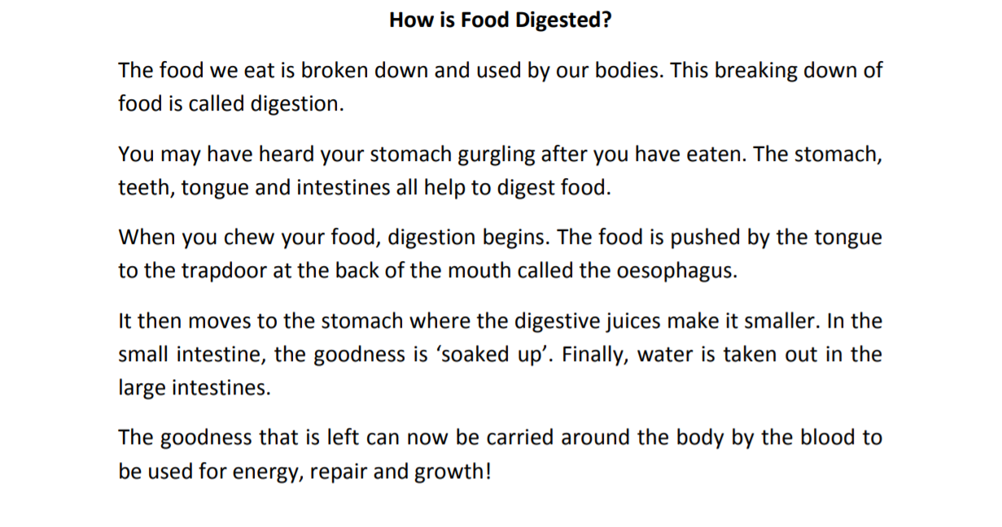

- Watch this link three times! https://www.youtube.com/watch?v=iFKB1HQgdIs called ‘How does soap kill the coronavirus?’

- CHALLENGE! Now start to have a go at writing your own explanatory text like the other ones you have read above, using the information from this clip. Can you explain how soap works to kill the virus? You may have to pause the video a few times to get the key or technical words from it!

OR INSTEAD OF THAT…

Can you start to write your own explanation for how something works? Some ideas might be:

- Why a volcano erupts
- The life cycle of the butterfly
- How mummies in Ancient Egypt were made
- How food chains work
- How a rainbow is formed
- Why an earthquake happens
- How people washed their clothes in the early 1900s (before washing machines were invented)

- Of course, you may have to do some research in books and/or the internet to help you understand it before you can explain it well yourself! Look for films for children on YouTube to help you. (Again, only use YouTube with permission and supervision from an adult.)

POINTS TO CONSIDER BEFORE WRITING
- What is it about? What are you explaining? Are you explaining how or why something happens or are you explaining a process?
- What is the title?
- What are the important parts, section of what you want to explain? How would you describe it and its parts? Which parts need to be described as part of the explanation?
- How does it work? What happens first, next and why?
- Can you include a labelled diagram?

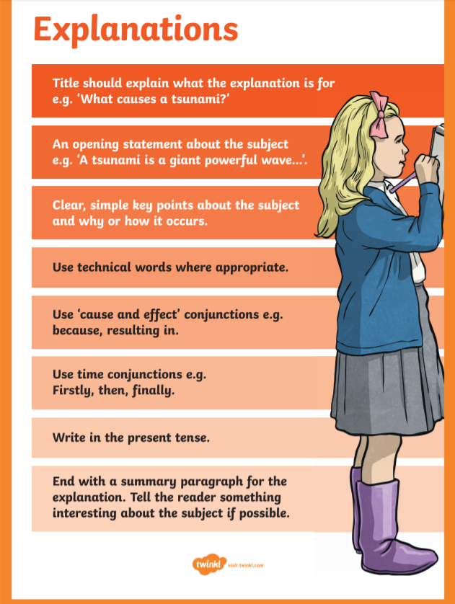

Day 7
- Mental Maths: Week 27 Tue and Problem Solving
- Read at Home: Do page 102
- Silent reading: 30 minutes
- Tables: Spend 10 minutes on either www.multiplication.com or https://www.topmarks.co.uk/maths-games/7-11-years/multiplication-and-division. Work on the Division questions.
- If you want further challenge: Pick a problem from https://nrich.maths.org/primary
- Spelling: Continue with the next five words you found out you didn’t know, as described in Day 1.
- Irish: Go online to https://www.duolingo.com/learn Spend ten minutes or so on the exercises.
- English Writing /Art:
- Finish writing your draft of your explanatory text.
- Draw a diagram for your explanatory writing from yesterday.
- Make sure to put labels with your pictures.

Day 8
- Mental Maths: Week 27 Wed and Problem Solving
- Read at Home: Do page 100 Silent reading: 30 minutes
- Tables: Spend 10 minutes on either www.multiplication.com or https://www.topmarks.co.uk/maths-games/7-11-years/multiplication-and-division. Work on the Division questions.
- Spelling: Continue with the next five words you found out you didn’t know, as described in Day 1.
- Irish: Go online to https://www.duolingo.com/learn Spend ten minutes or so on the exercises.
- English Writing:
- Go back over your first draft.
- Edit and revise your writing. Make sure you have used time conjunctions somewhere in it and if possible cause and effect conjunctions.
- Check over it for capital letters, full stops, punctuation and spellings.
- Read it out to someone at home to check that it makes sense and teach them something new!
- With an adult’s permission, you could always record yourself reading your explanation and then send it in to us so we can share it on the school website!

Day 9
- Mental Maths: Week 27 Thurs and Problem Solving
- Read at Home: Do page 99 Silent reading: 30 minutes
- Tables: Spend 10 minutes on either www.multiplication.com or https://www.topmarks.co.uk/maths-games/7-11-years/multiplication-and-division. Work on the Division questions.
- Spelling: Continue with the next five words you found out you didn’t know, as described in Day 1.
- Irish: Go online to https://www.duolingo.com/learn Spend ten minutes or so on the exercises.
- Maths - Decimals: Watch this film about decimals https://mathantics.com/lesson/decimal-arithmetic as far as 3 mins 40 secs (however, if you’re interested in learning more feel free to watch to the end!) Don’t worry about going back and watching other videos that he talks about at the start. – just keep watching.
HINT: He talks about lining up the ones places. Ones places is the same as saying the Units places.
- Now complete questions 1 and 2 from below. Write them out in your copy. Remember to line them up properly using the decimal point. Use a calculator to correct.
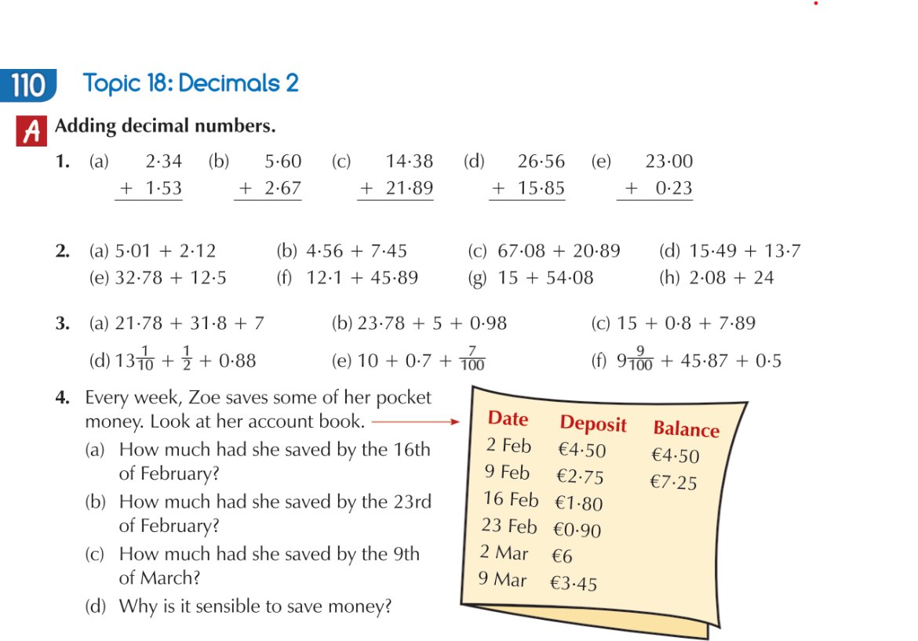

Day 10
- Mental Maths: Week 27 Fri review and Problem Solving
- Read at Home: Do page 98 Silent reading: 30 minutes
- Tables: Spend 10 minutes on either www.multiplication.com or https://www.topmarks.co.uk/maths-games/7-11-years/multiplication-and-division. Work on the Division questions.
- Spelling:
- Continue with the next five words you found out you didn’t know, as described in Day 1.
- Get someone to give you a written test you on all the spellings you have been working on for the past two weeks.
- Irish: Go online to https://www.duolingo.com/learn Ten minutes practice.
- Maths - Decimals: Watch this film about decimals again to remind yourself about how to add decimals. https://mathantics.com/lesson/decimal-arithmetic as far as 3 mins 40.
- Now complete questions 3 and 4 from ‘Adding decimal numbers’ above. Write them out in your copy. Remember to line them up properly using the decimal point. Use a calculator to correct them after.

The Basic Spelling Vocabulary List
The trickier ones have an asterisk * beside them – think of ways you might remember the tricky bits from them!

Grade 1
a  all  am*  and*  at  ball  be  bed  big  book  box  boy*  but  came*  can*  car  cat  come*  cow  dad  day*  did  do  dog* | fat  for  fun*  get*  go  good*  got*  had*  hat  he*  hen  here  him*  his*  home*  hot  I*  if  in*  into*  is  it*  its*  let | like*  look  man  may  me*  mom  my*  no*  not  of  oh  old  on*  one*  out*  pan  pet  pig  play*  ran  rat  red  ride  run | sat  see  she  sit  six  so  stop  sun  ten  the*  this  to*  top  toy  two*  up  us  was*  we*  will*  yes  you*

Grade 2
about*  add  after  ago  an*  any  apple  are*  as  ask  ate  away  baby*  back  bad  bag  base  bat  bee  been*  before*  being  best  bike  bill  bird  black  blue  boat  both  bring  brother*  brown  bus  buy*  by  cake  call  candy  change  child  city  clean  club  coat  cold  coming*  corn  could  cry  cup  cut  daddy*  dear  deep  deer  doing  doll  door  down*  dress  drive  drop  dry  duck  each  eat  eating  egg  end  fall  far  farm  fast | father*  feed  feel  feet  fell*  find  fine*  fire  first*  fish  five  fix  flag  floor  fly  food  foot  four  fox  from*  full  funny  game  gas  gave  girl  give  glad  goat  goes*  going*  gold  gone  grade*  grass  green  grow  hand  happy  hard  has*  have*  hear*  help  here*  hill  hit  hold  hole  hop  hope*  horse  house*  how*  ice  inch  inside*  job  jump  just*  keep  king  know*  lake  land  last  late  lay  left  leg  light  line  little*  live | lives  long  looking  lost  lot  love  mad  made*  make*  many*  meat  men  met  mile  milk  mine  miss  moon  more  most  mother*  move  much*  must  myself*  nail  name*  need  new*  next  nice*  night  nine  north  now*  nut  off*  only  open  or*  other  our  outside*  over  page  park  part  pay  pick  plant  playing  pony  post  pull  put  rabbit  rain  read  rest  riding  road  rock  room  said*  same  sang  saw*  say  school*  sea  seat  seem  seen  send* | set  seven  sheep  ship  shoe  show*  sick  side  sing  sky  sleep  small  snow  some*  soon*  spell  start  stay  still  store*  story  take  talk  tall  teach  tell  than*  thank  that  them*  then*  there*  they*  thing  think*  three  time*  today*  told  too*  took  train*  tree  truck  try  use  very*  walk  want*  warm  wash  way  week  well*  went*  were*  wet  what  when*  while*  white  who  why  wind  wish  with*  woke  wood  work  yellow  yet  your  zoo

Grade 3
able  above  afraid  afternoon*  again*  age  air  airplane  almost  alone  along*  already*  also  always*  animal  another*  anything*  around*  art  aunt*  balloon*  bark  barn  basket  beach  bear  because*  become  began  begin  behind  believe*  below  belt  better  birthday*  body  bones  born  bought*  bread  bright  broke  brought*  busy  cabin  cage  camp  can't*  care  carry  catch  cattle  cave  children*  class  close*  cloth  coal  colour  corner  cotton  cover  dark  desert  didn't*  dinner  dishes  does  done  don't*  dragon  draw  dream  drink  early  earth  east  eight | even  ever  every*  everyone*  everything*  eyes  face  family*  feeling  felt  few  fight  fishing  flower  flying  follow  forest  forgot  form  found*  fourth  free  Friday  friend*  front  getting*  given  grandmother  great  grew  ground  guess*  hair  half  having*  head  heard*  he's*  heat  hello*  high  himself  hour  hundred  hurry  hurt*  I'd*  I'll*  I'm*  inches  isn't  it's*  I've*  kept  kids  kind  kitten  knew*  knife  lady  large  largest  later  learn  leave  let's*  letter*  life  list  living  lovely  loving*  lunch  mail  making  maybe*  mean  merry  might* | mind  money*  month  morning*  mouse  mouth  Mr.*  Mrs.*  Ms.  music  near  nearly  never  news  noise  nothing  number  o'clock*  often  oil  once*  orange  order  own  pair  paint  paper  party*  pass  past  penny  people*  person  picture  place  plan  plane  please*  pocket  point  poor  race  reach  reading  ready  real  rich  right*  river  rocket  rode  round  rule  running*  salt  says  sending  sent*  seventh  sew  shall  short  shot  should  sight  sister  sitting  sixth  sled  smoke  soap  someone*  something*  sometime*  song  sorry  sound  south  space | spelling  spent  sport  spring  stairs  stand  state  step  stick  stood  stopped*  stove  street  strong  study  such  sugar  summer*  Sunday*  supper  table  taken  taking  talking  teacher*  team  teeth  tenth  that's*  their  these*  thinking  third  those  thought*  throw  tonight*  trade  trick  trip  trying  turn  twelve  twenty  uncle  under  upon*  wagon  wait  walking  wasn't  watch  water  weather*  we're*  west  wheat  where*  which  wife  wild  win  window  winter  without  woman*  won  won't*  wool  word  working  world*  would*  write*  wrong  yard  year  yesterday  you're*

Grade 4
across  against  answer*  awhile*  between  board  bottom  breakfast  broken  build  building  built  captain*  carried  caught*  charge*  chicken  circus  cities  clothes*  company  couldn't*  country  discover  doctor*  doesn't  dollar | during  eighth*  else  enjoy  enough  everybody*  example  except  excuse  field*  fifth  finish  following  good-by*  group  happened*  harden  haven't*  heavy  held  hospital*  idea  instead*  known  laugh  middle  minute | mountain  ninth  ocean  office  parent  peanut  pencil  picnic  police  pretty*  prize  quite*  radio  raise  really*  reason  remember*  return  Saturday*  scare  second  since  slowly  stories  student  sudden  suit | sure*  swimming*  though  threw*  tired  together*  tomorrow*  toward  tried*  trouble  truly*  turtle  until*  village  visit  wear  we'll  whole*  whose  women  wouldn't*  writing*  written  wrote  yell  young

Grade 5
although  America  among  arrive  attention  beautiful*  countries  course*  cousin*  decide | different*  evening  favourite  finally*  future  happiest  happiness  important  interest  piece | planet  present  president  principal*  probably*  problem  receive*  sentence  several  special | suddenly  suppose*  surely*  surprise*  they're*  through  usually

