Sixth Class Room 9 June 2nd – 5th
Hi all,
Thanks for sending your photos and Fact File information so promptly. The photos are incredibly cute. I’m really enjoying the opportunity to see them and read the information about yourselves.
The Narrative stories which I received were so well written. I really enjoyed reading them. They were exciting and you all made an amazing effort to use very advanced language. I wonder will we have any future English graduates in the class.
When you collect your school books and copies during the next few weeks, will you please remember to return any school library books which you borrowed?
Remember not to dispose of the contents of your folders during the summer! Hopefully some of the sections will be of great use to you in first year.
Below is the week’s work for Tuesday to Friday. Monday as you know is a bank holiday.
Do your best to complete as much of it as possible.

- Spellings:
Page a week (as usual)
Please send your Friday test result to me.

- Mental Maths:
Test a day (Monday to Friday)
Correct your answers if you have access to the internet
https://www.newwavementalmaths.ie/my-login/
Email JMerry@scoilchaitrionasns.ie Password Mental1
6th Class : Practice
If you do not understand any of the questions, please email me and I will explain the answers. Remember to send your weekly score to me.

- Tables:
Multiplication: Spend 10 minutes daily on either of the following websites.
multiplication.com free click on Games and do multiplication and division games
topmarks.co.uk click on Times Tables
If you do not have access to the internet, learn the tables the usual way using a table book.

- Read at Home:
Read a page each day (Monday to Friday) Answer the questions orally. There’s no need to write the answers this week because you will be completing different writing.

- Writing:
Tuesday:
- Read the poem I See His Blood upon the Rose by Joseph Mary Plunkett below.
- Learn a verse each day if possible.
- Write about the poem: In your opinion what does the poet mean in each verse? Do you like the poem? Write any additional information you choose. Paragraph your work. Try to write at least one and a half pages. There are no correct answers! Send this to me please at the end of the week.
Wednesday:
- Read the article “Labels” below. Answer the questions. Work for at least twenty minutes on this article.
- Learn the second verse of the poem “I See His Blood upon the Rose.”
Thursday:
Read the article “How do Rainbows Occur” below.
In your copy:
- a. Write 10 questions based on this Explanation Writing.
- Look up the words typed in bold in your dictionary or online.
- Learn the final verse of the poem.
Friday:
- Write your own Explanation Writing based on a theme of your choice.
Send this to me please.
- Revise the complete poem. I know some of you will have mastered it.

- Scéal:
We’ll be revising scéalta in your folder again this week. Try to learn two paragraphs a day (instead of one) and write them as we do. Score yourself. This learning will help you greatly in secondary.
Tuesday and Wednesday: Mo Chara
Thursday and Friday: Mo Bhreithlá

- Am don Léamh:
Answer A-D
This week there’s no need to learn the abairtí because you’ll be learning the scéalta from your folder.
I have answers for the scéal you have completed below. Please do any ceartúcháin necessary on your page in red pen.

- Duolingo:
Gaeilge: 10/15 minutes a day (If you have access to the internet)

- Read:
15 minutes or more daily (any books at home)

- Maths:
I have a revision sheet attached below for you to complete. Do 5 questions each day. Use your maths copy to answer them. Use your Maths Rules for help.
The answers of the previous week’s questions are below also. Please correct your work and do corrections if you made any mistakes.

Am don Léamh: Freagraí
Ceolchoirm U2: L. 37
- 1. Fíor 2. Bréagach 3. Bréagach 4. Fíor 5. Fíor 6. Bréagach
- 1. Thug Lára na ticéid dó / do Ruairí.
2. Chuaigh Ruairí, Lára agus aintín Ruairí.
3. Bhí (na) soilse ar lasadh.
4. Thosaigh siad ag béiceadh nuair a chonaic siad Bonó.
5. Bhí spéaclaí gréine buí air / ar Bonó.
6. Cheannaigh sé t-léine di / do Lára.
- 1. ceolchoirm 2. Lára 3. soilse 4. Beautiful Day
- Sé, ticéad, soilse, do ……..
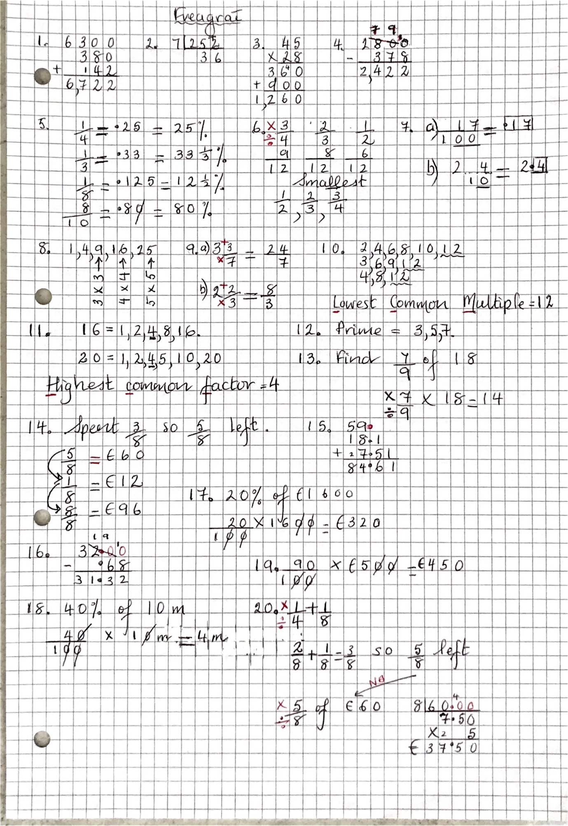

Maths for this week. Answer 5 questions a day.