Ms Merry’s 4th Class 18/5/2020
Week 7

Hi all! Great to keep hearing from people through email. Try to correct your mental maths either as you go along each day or at the end of the week. If you are stuck on the problem-solving and can’t figure out where the answer came from, email me and I will try to explain. 😁
Remember that the activities highlighted in red, is the work I want you to send me on the Friday of that week. Here is it for this week:
WORK TO SEND ON FRIDAY TO MY EMAIL
jmerry@scoilchaitrionasns.ie

- Your score for your spelling test that you will be doing on Friday from the list below.

- Your book review that you will have done by the end of the week.

- Five more sentences from Duolingo you will have learned this week.

- Your answers to the questions you will have done from your geography book.

Day 1
- Mental Maths corrections: Make sure you have corrected your work up as far as you have done.

https://www.newwavementalmaths.ie/my-login/

Log in: JMerry@scoilchaitrionasns.ie and the password is Mental1.

- Mental Maths: Week 29 Mon and Problem Solving

- Irish: Go online to https://www.duolingo.com/learn Spend ten minutes or so on the exercises.

- Spelling writing: These are your spellings for this week in the box below.

Choose 12 of them (try to include ones that you don’t actually know the meaning of already!) and write a sentence for each as it says below.

If you don’t know what a word means, look up this online dictionary https://kids.wordsmyth.net/we/ (you put the word you are looking for in the box on the left-hand side).

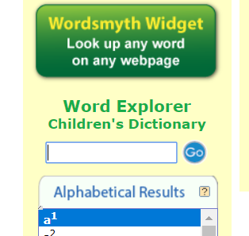
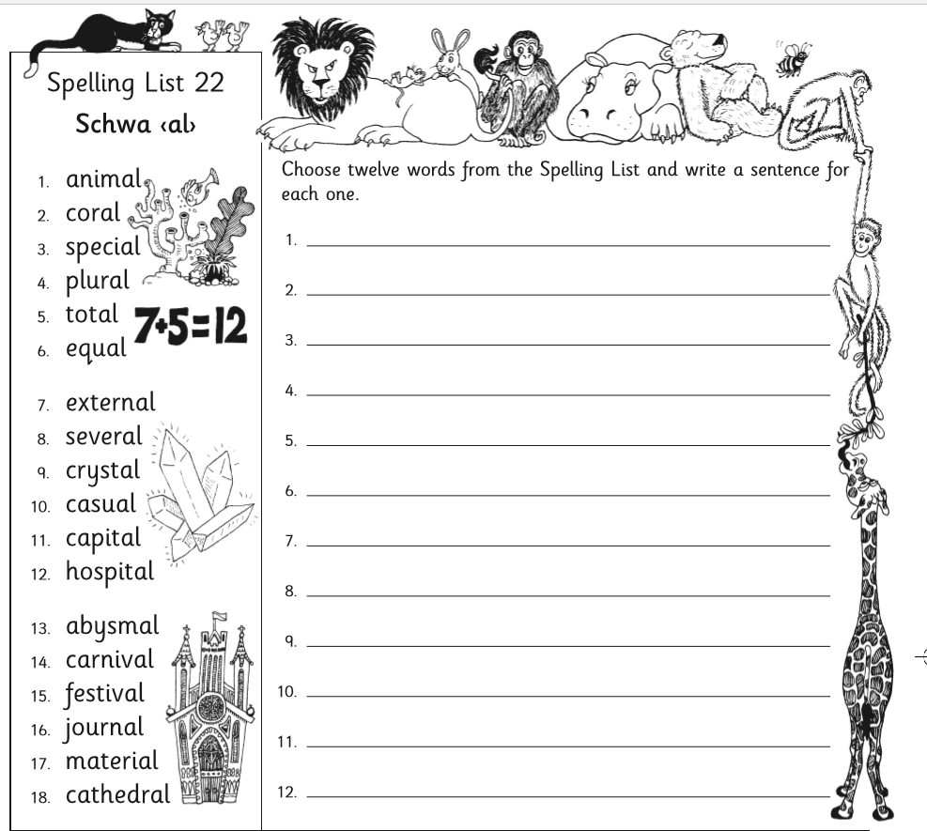

- Spelling learning: Look at the first 6 spellings – say the letters of each, picture in your head, write them and check your answer. Now write each one again, without looking and check if you know it.
- Book Review: Watch this storybook video, called ‘If I never forever endeavour’.

https://www.youtube.com/watch?v=EeQX4DCAi9I

- Think! What would you write if you had to review this book? Look up the word ‘endeavour’ in the dictionary to find its meaning.
- Now read the review this girl wrote about it.

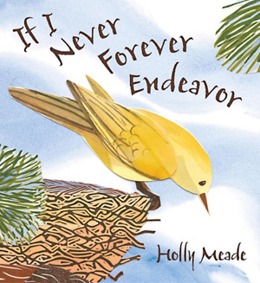

Book Review of ‘If I never forever endeavour’
By Hayden

This book was about a bird who didn't yet know how to fly.
The bird has to decide if it will try to fly, but it was not sure if it wants to. The bird thought, "If I never forever endeavour" then I won't ever learn. On one wing, he worries he might fail and on the other wing he thinks of how he may succeed. He worries that if he tries, he may get lost in the world. That makes him want to stay in his nest where he's safe.
I think this book would help other children to learn that trying new things can be scary, but sometimes when we try, we can find things that make us happy too. And this book will help others know that mistakes are okay and part of learning.
My favourite part is that the bird tried and learned that she could fly. I also liked that I read this book because it gave me a chance to talk to mom about making mistakes and how I don't like making them. Then I learned they are good and part of learning.
Boys and girls who are 3 to 8 years old would like this book because it teaches about trying a new thing and how it's important to get past being scared so you can learn new things.
I give the book 5 stars since I think it's important for other children to learn about courage.

Day 2
- Mental Maths: Week 29 Tue and Problem Solving
- Silent reading: 30 minutes
- Spelling: As above. Learn how to spell the next 6 spellings from the list above.
- Irish: Go online to https://www.duolingo.com/learn Spend ten minutes or so on the exercises.
- Book Review: Can you remember anything you have read about marsupials before? Read the review for this book.

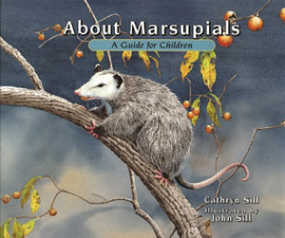
Book Review of ‘About Marsupials’
By Conor

‘About Marsupials’ is the title so the book is about...marsupials, of course! It's non-fiction. I really think everyone would like the book. I think someone who likes animals would especially like to read it.
The glossary of facts in the back of About Marsupials is the most useful part. I thought the most interesting parts were that some marsupials have their pouch at their back legs and one marsupial, the Yellow-footed Rock Wallaby, is very small but can jump 13 feet wide!
Kids in the 4-8 age range would like this book. Even though it's not a story book, 4-year olds would like the few words on each page and they would love the beautiful pictures. But older kids would like it because of all the facts in the back of the book. There's a lot of information for each animal. I think boys and girls (and parents) would enjoy reading it. This book is very interesting. I give it 4 stars.

- Geography Book: What do you already know about ‘Homes’? Think about all the words that come to mind when you hear that word. Now read pages 57, 58, 59 and 60. Think about what you are going to write for the answers to the questions on these pages. You might need to chat to other people in your house about them too.

Day 3
- Mental Maths: Week 29 Wed and Problem Solving
- Silent reading: 30 minutes
- Spelling: As above, next 6.
- Irish: Go online to https://www.duolingo.com/learn Spend ten minutes or so on the exercises.
- Book Review:
Time to write your book review in your copy!
Choose a book you have read.
You can even choose a simple picture book that is in your house to write your review about.
Answer the following questions in the coloured boxes below to help you write it.
Use a different paragraph for the answers from each box so you will have four paragraphs at the end.
Remember to put a title at the top – and best handwriting!

(Note: ‘credible’ means ‘believable’ or ‘realistic’)

Book Review Planning Questions

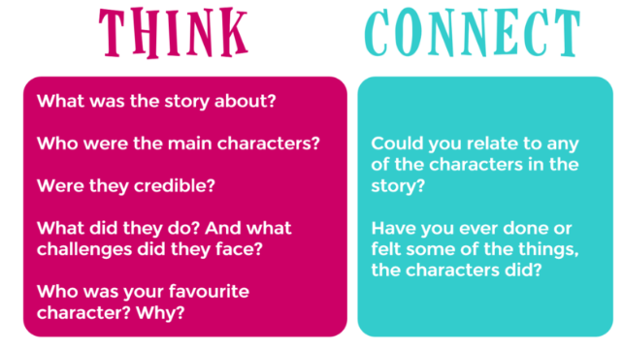

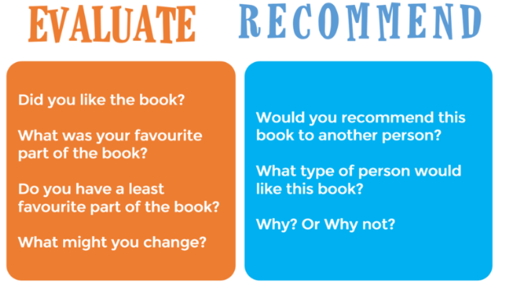

Day 4
- Mental Maths: Week 29 Thurs and Problem Solving
- Spelling: Revise all the spellings you did this week by using look, cover, say the letters, write and check for the ones you found tricky.
- Irish: Go online to https://www.duolingo.com/learn Spend ten minutes or so on the exercises.
- Geography Book: Read again the pages you read previously and now write the answers to the questions on page 57 and 58.
- Maths: Watch this film on how to multiply decimal numbers by a whole number. You might want to watch it two or three times. https://www.youtube.com/watch?v=yRpFTycg2z0
- Now try these sums below. For number 3 remember to change the fraction to a decimal. Correct with a calculator. I will send you the answers and how to work them out next week.

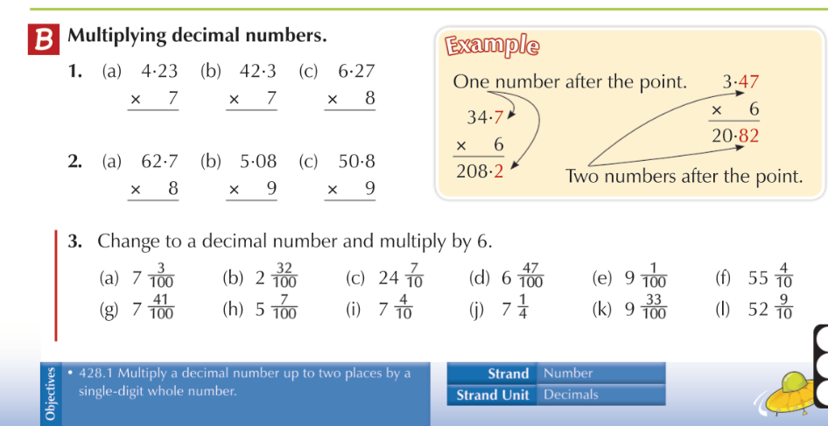

Day 5
- Mental Maths: Week 29 Fri review and Problem Solving
- Irish: Write down your 5 Irish sentences with the meanings for sending to me.
- Spelling: Ask someone at home to give you a test on these spellings. Good luck
- Geography Book: Do the questions on page 60 in your copy. Read page 61 about homelessness.
- Maths: Watch these two short films on how to multiply decimal numbers by a whole number.

- First video https://www.khanacademy.org/math/algebra-basics/basic-alg-foundations/alg-basics-operations-with-decimals/v/subtracting-decimals-up-to-hundredths

- Second video https://www.khanacademy.org/math/arithmetic-home/arith-review-decimals/sub-decimals/v/another-example-subtracting-decimals-to-hundredths

- Now have a go at doing these questions below in your copy.

- For Q2, Q3 and Q4 you need to write them vertically like Q1 is written. Then do a take-away. You may have to regroup! Remember ‘More on the floor? Go next door!’

- For Q4 you will need to put in the invisible zeroes so (a) will actually be 5.60 – 3.56 (b) will be 9.70 – 1.85. Can you figure out how you will write (c) and (d)? Remember to put your decimal point in the answer!

- Have a go at finding the answers out on your calculator and put a red tick beside the ones you got correct and a dot beside the ones you had errors in. I will give you the answers next week.

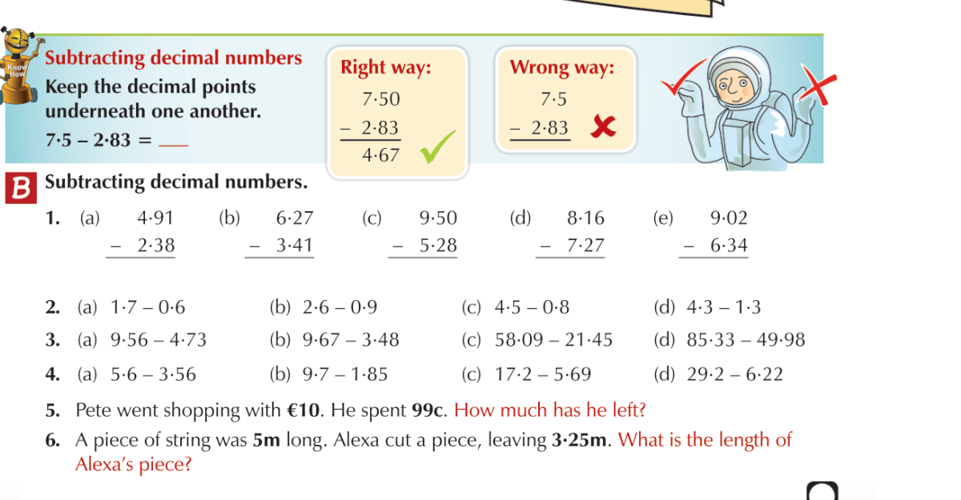

- Optional: Pick an activity from page 63 in the geography book to do and let me know what you did by email!

