Sixth Class Room 9 May 25th – 29th
Hi all,
I’m delighted to hear that you’re well and filling your hours with exercise, fun activities, baking and so on.
The standard of your Covid 19 projects is extremely high. You are certainly well equipped for secondary. The schools which you will join in September will be very lucky to have you. Not only will they receive hard working, determined students but you are also a mature, friendly and kind group.
Send your photos and typed page directly to me as soon as possible. The details can be found on Ms. Whelan’s letter to 6th class on the Home School Learning section. That will be your English work for Monday and Tuesday.
Below is the week’s work. Do your best to complete as much of it as possible.

- Spellings:
Page a week (as usual)
Please send your Friday test result to me.

- Mental Maths:
Test a day (Monday to Friday)
Correct your answers if you have access to the internet
https://www.newwavementalmaths.ie/my-login/
Email JMerry@scoilchaitrionasns.ie Password Mental1
6th Class : Practice
If you do not understand any of the questions, please email me and I will explain the answers. Remember to send your weekly score to me.
- Tables:
Multiplication: Spend 10 minutes daily on either of the following websites.
multiplication.com free click on Games and do multiplication and division games
topmarks.co.uk click on Times Tables
If you do not have access to the internet, learn the tables the usual way using a table book.

- Read at Home:
Read a page each day (Monday to Friday) Answer the questions orally. There’s no need to write the answers this week because you will be completing different writing.

- Writing:
There are two tasks this week.
Monday and Tuesday:
Prepare and send the information page and four photos to me. If you have a problem with this, email me and I’ll hopefully be able to guide you. If possible, send your completed work and photos on Tuesday or Wednesday please.
- Type the information: There is no need to write any more than three quarters of a typed page. The details of the paragraphs are on Ms. Whelan’s letter to 6th class, which is on our website.
- Take a photo of the four photos you are choosing and send them as an attachment.
Wednesday, Thursday and Friday:
Complete a mini project on one of the famous Irish artists/creators listed below.
- Harry Clarke (stained glass work eg. Belcamp College)
- Evie Hone (stained glass work eg. Manresa House, Clontarf)
- Eileen Gray (furniture designer)
Present the work as you wish: In your A4, in a copy or on loose pages.
Suggestions: Birth (place and date), family, education, style of work, samples of art, current locations of work, death (place and date) and so on.
The artists in the class could attempt to copy some of the famous works of your chosen person.
Perhaps look up some auction results and learn how valuable the works/items in question have become.
Is it possible to see any of the famous works of art?
Harry Clarke and Evie Hone: National Gallery of Ireland
Eileen Gray: National Museum of Ireland

If you haven’t got access to the internet, answer Read at Home questions instead of doing the project.

- Scéal:
We’ll be revising scéalta in your folder again this week. Try to learn two paragraphs a day (instead of one) and write them as we do. Score yourself. This learning will help you greatly in secondary.
Monday: Mé Féin complete
Tuesday and Wednesday: Mo Chaitheamh Aimsire
Thursday and Friday: Ar Scoil

- Am don Léamh:
Scéal each week. Answer A-D
This week there’s no need to learn the abairtí because you’ll be learning the scéalta from your folder.
I have answers for the scéal you have completed below. Please do any ceartúcháin necessary on your page in red pen.

- Duolingo:
Gaeilge: 10/15 minutes a day (If you have access to the internet)

- Read:
15 minutes or more daily (any books at home)

- Maths:
I have a revision sheet attached below for you to complete. Do 4 questions each day. Use your maths copy to answer them. Use your Maths Rules for help.
The answers of the previous week’s questions are below also. Please correct your work and do corrections if you made any mistakes.

Am don Léamh: Freagraí
An Cárta Breithlae: L. 35
- 1. Bréagach 2. Fíor 3. Fíor 4. Fíor 5. Fíor 6. Fíor
- 1. Breithlá Ruairí a bhí ann. / Bhí breithlá Ruairí ann
2. Bhí sé dhá bhliain déag d’aois. (1-6+h)
3. Tháinig Lára go dtí an chóisir.
4. D’ith siad criospaí, grán rósta, uachtar reoite and cáca breithlae.(of)
5. Chuaigh sí abhaile ar a naoi a chlog. (a+h)
6. Fuair sé dhá thicéad do cheolchoirm U2 i bPáirc an Chrócaigh.(i+urú)
- 1. Ar an doras 2. Ina lámh 3. Ar DVD 4. Sa chárta (sa +h)
- Cá, aois, doras, do, di, cóisir ……..

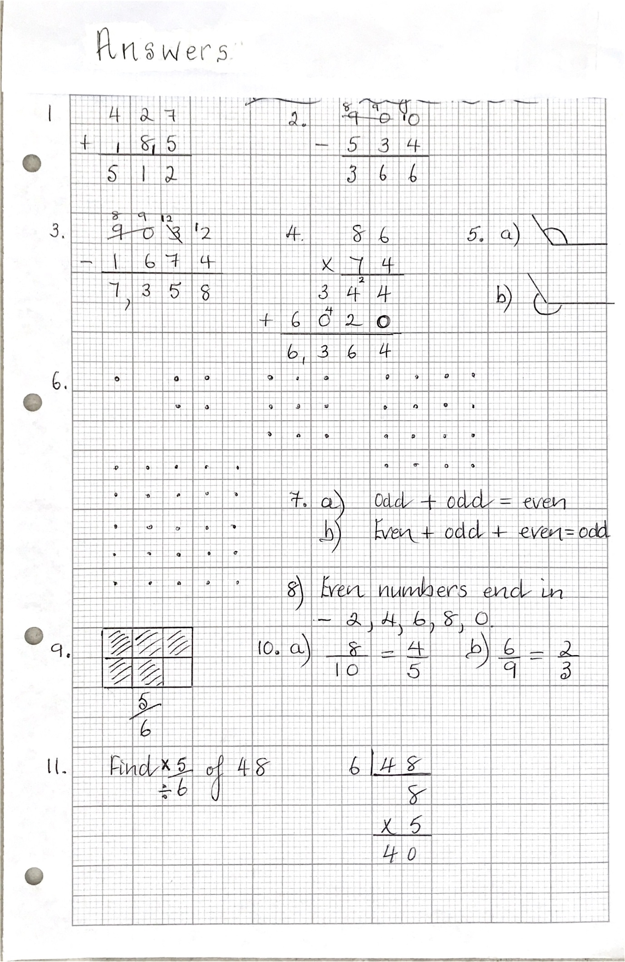
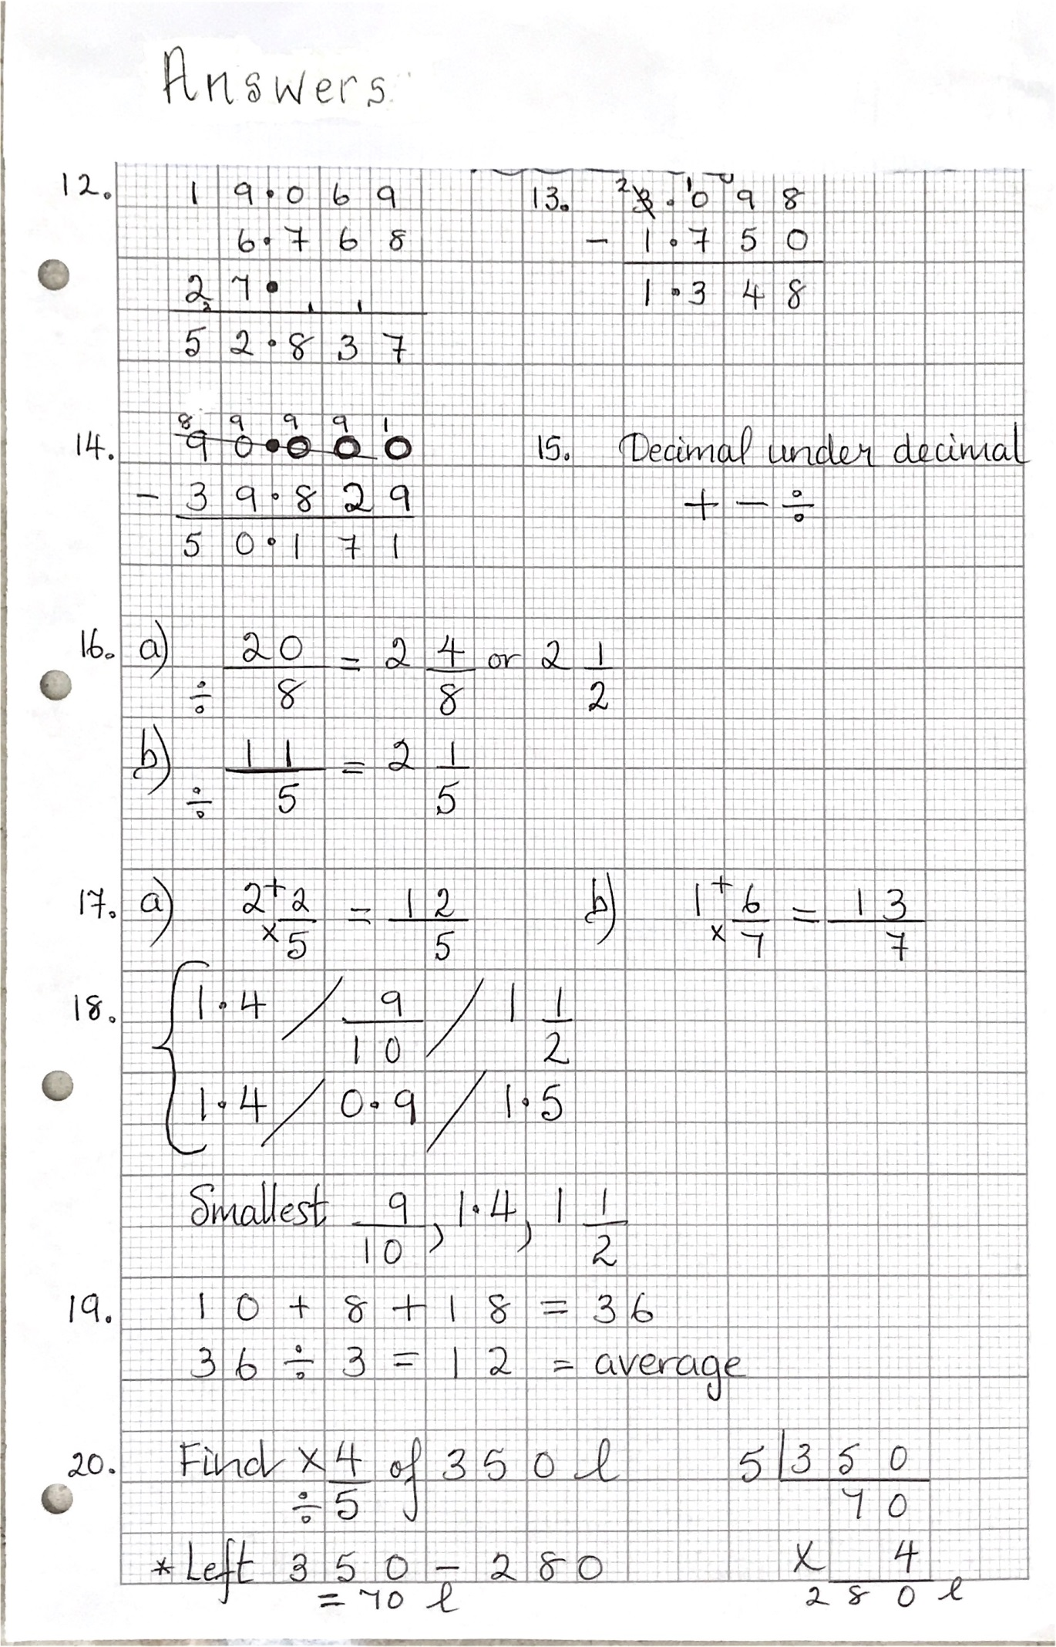
Maths for this week. Answer 4 questions a day.
