Ms Merry’s 4th Class 24/4/2020

Work for Week 5

Hi all! Great to hear from people through email. Just a note to say that you don’t need to send me your Read at Home or Mental Maths answers. Part of your weekly work will be to correct this work using the answers I send you and the Mental Maths website. Try to correct your mental maths either as you go along each day or at the end of the week. If you are stuck on the problem-solving and can’t figure out where the answer came from, email me and I will try to explain. 😁

Remember that the activities highlighted in red is the work I want you to send me on the Friday of that week. Here is it for this week:
WORK TO SEND ON FRIDAY TO MY EMAIL jmerry@scoilchaitrionasns.ie
- Please send me your score for your ‘Read at Home’ answers that you corrected this week.
- Please send me 5 sentences that you have learned from duolingo. Write them in Irish and write the translation (meaning) beside them.
Example: Anne is ainm dom = Anne is my name
- Have someone test you on all the spellings you have learned so far and send me the score you got.

Day 1
- Mental Maths corrections: Make sure you have corrected your work from the past two weeks.

https://www.newwavementalmaths.ie/my-login/
Log in: JMerry@scoilchaitrionasns.ie and the password is Mental1.

- Mental Maths: Week 28 Mon and Problem Solving
- Read at Home corrections: Use the answers below to correct all your questions from Day 3 to 6.

Read at Home Answers Week 3 + 4
Day 3: The Sahara Desert - Page 106
- The Sahara Desert is in North Africa.
- The Atlantic Ocean lies to the east of the Sahara Desert.
- People who live in the desert are called nomads.
- An oasis is the name of a fertile place in the desert.
- A mirage is when a traveller thinks they see lakes of water in the distance. It is a trick of the light.

Day 4: Big Shot - Page 105
- Chris digs holes in the golf course because he is terrible at it. Whenever he swings to hit the ball, he takes out part of the golf course.
- Chris went down to the beach behind his house and threw stones crossly into the sea to show his frustration.
- The school decided to enter the shot-putt competition.
- The PE teacher expected that Chris would not be too good at it.
- The stone-throwing paid off for Chris because he could throw the shot-putt really well.

Day 5: TV Channel Guide - Page 104
- Robert Duffin saved three children from a burning house last week.
- The stars of the afternoon film are Mylie De Lerious and Lewis Cannon.
- Rare desert hedgehogs are mentioned in the Channel Guide.
- Justin Tyme is a private investigator.
- The programmes which feature music are 'Daybreak with Debbie Yeats' and 'The Music Show'.

Day 6: The Seven Wonders of the Ancient World - Page 103
- Three pyramids were found at Giza in Egypt.
- The modern countries where these wonders were found are Egypt, Iraq, Greece and Turkey.
- The statues on the list are 'The Statue of Zeus', statues from 'The Tomb of Mausolus' and 'The Colossus of Rhodes'.
- 'The Tomb of Mausolus' is a tomb.
- Three wonders were destroyed by earthquakes.
_________________________________________________

- Writing and Grammar: Conjunctions are connecting words.

Here are the answers for A and B. Correct them now in your copy.

1. before
2. and
3. when
4. after
5. if
6. because

Here are some example answers for B

- Ben turned around and waved to me.
- I picked up the shattered pieces after the wind blew the vase over and it broke.
- I love it when the sun shines.
- Sarah felt sad because her friend was leaving for good.
- Teacher will be cross if we leave people out of our games.
- Anna checked her parachute before jumping out of the plane.

- Tables: Spend 10 minutes on either www.multiplication.com or https://www.topmarks.co.uk/maths-games/7-11-years/multiplication-and-division. Work on the Division questions.
- Spelling:

Do these activities to help you learn the words:

- Write them in different colours in your copy
- Write them in the air
- Write them on someone’s back (with your finger!)
- Type them out each five times each
- Say the letters in the word out loud quickly three times
- Write them into a silly sentence
- Then, see if you can remember them by writing them again without looking at them.

Already know all of Grade 4? Go on to Grade 5 words.
For those really tricky ones try the SOS method. You may need help from an adult or older sibling:
https://localoffer.haltonchildrenstrust.co.uk/wp-content/uploads/2015/12/SOS-Spelling-Method.pdf

Day 2
- Mental Maths: Week 28 Tue and Problem Solving
- Read at Home: Use the answers below to correct all your questions from Day 7 to 10.

Read at Home Answers from weeks 3 and 4
Day 7: Page 102
- Hans Lippershey used to make spectacles. In 1608, he made his first telescope.
- He was Dutch so he came from the country of the Netherlands.
- Galileo lived in Italy.
- He discovered the rings of Jupiter and four of its moons. He also discovered that the Earth moved around the sun.
- The Hubble telescope has helped astronomers to see far away stars. It has also been used to find hundreds of planets in orbit around those stars.

Day 8: Page 100
- Idioms are common sayings that may seem a bit strange if you think about them. However, each of them has an explanation to how it started.
- (a) ‘As clear as a bell’ means the explanation was easy to understand.
(b) ‘Bite the bullet’ means to take what’s coming without complaining.
- (a) ‘Black sheep’ means he or she is the one in the family who is the most trouble.
(b) ‘Spanking new’ means brand new.
- (a)Her voice rang out across the hall as clear as a bell.
(b) When all this extra work comes along we’re just going to have to bite the bullet.
- ‘Hit the nail on the head’ means to get something exactly right. You won’t drive a nail in properly into wood without hitting it directly on the head with the hammer.
‘Speak of the devil’ means that when you are talking about that person they directly appear. It comes from the Middle Ages when people were very superstitious and were not allowed to talk about the devil or evil because if they did, they believed it would appear.
If you are interested you can check more of them out here! https://www.smart-words.org/quotes-sayings/idioms-meaning.html

Day 9: Page 99
- The poem is set in the jungle.
- A tiger jumped out in front of the poet.
- He was going to devour (eat) him, starting with his liver.
- The poet said had twenty children.
- Yes, I think the tiger was nice because he decided not to eat him in the end as he didn’t want to leave behind a widow and twenty children.

Day 10: Page 98
- Early in the morning, flocks of parrots go hunting for food.
- Females generally lay their eggs in December.
- The parents eat fruit and nuts and then when they get back to their chicks they regurgitate it into the chicks’ mouths.
- The animals that prey on parrots are toucans, tree snakes like boas, and eagles.
- The most well-known breed of parrot is the macaw.

- Silent reading: 30 minutes
- Tables: Spend 10 minutes on either www.multiplication.com, https://www.topmarks.co.uk/maths-games/7-11-years/multiplication-and-division. Work on the Division questions.
- Spelling: Continue with the next five words you found out you didn’t know.
- Irish: Go online to https://www.duolingo.com/learn Spend ten minutes or so on the exercises.

If you want a challenge...
- Choose a cartoon to watch as Gaeilge - https://www.cula4.com/en/watch/

Day 3
- Mental Maths: Week 28 Wed and Problem Solving
- Geography Correct the work you did in the very first week using these answers.

Window on the World Geography Answers Week 1 + 2

Day 1: Page 18 answers
- Athlone - Co. Westmeath
- Dundalk - Co. Louth
- Limerick - Co. Limerick
- Newry - Co. Armagh or Co. Down
- Bray - Co. Wicklow
- Ennis - Co. Clare
- Naas - Co. Kildare
- Portlaoise - Co. Laois
- Clonmel - Co. Tipperary
- Enniskillen - Co. Fermanagh
- Navan - Co. Meath
- Tralee - Co. Kerry

Day 2: Page 19 answers
- The cities and towns which have grown in population since the 2002 Census include Dublin, Cork, Limerick, Galway, Waterford, Drogheda, Dundalk, Swords, Bray, Navan (all of the cities and towns).
- The population of Dublin has increased the most.
- I think the population of Dublin increased the most as it is the capital city of Ireland and it provides the most job opportunities for people.
- Drogheda, Dundalk, Swords and Bray have swapped places on the top 10 list since the 2002 Census.

Day 3: Page 21 Question time (1-7) answers
- The cities and towns with the same name as the county include Dublin, Cork, Limerick, Galway, Waterford, Derry, Armagh, Monaghan, Cavan, Sligo, Roscommon, Longford, Carlow, Kilkenny and Wexford.
- Dublin is the capital city of Ireland.
- Five cities or towns in Ireland beginning with 'C' are Cork, Cavan, Carlow, Clonmel and Castlebar. (Also Carrick on-Shannon)
- The ten largest cities and towns in terms of population/size in Ireland are Dublin, Cork, Limerick, Galway, Waterford, Drogheda, Dundalk, Swords, Bray and Navan.
- Five towns in my county are Coolock, Artane, Finglas, Santry and Howth. (There are many answers here!)
- My favourite town or city in Ireland is Dublin city because I think they have the best shops in the country. (Your own choice - just say why!)
- I would most like to visit Cork because it is known to be the food capital of Ireland and I love food! (Again it's your own choice as long as you say why!)

- Silent reading: 30 minutes
- Tables: Spend 10 minutes on either www.multiplication.com or https://www.topmarks.co.uk/maths-games/7-11-years/multiplication-and-division. Work on the Division questions.
- Spelling: Continue with the next five words you found out you didn’t know.
- Irish: Go online to https://www.duolingo.com/learn Spend ten minutes or so on the exercises.

Challenge Area (optional) - Maths Game!
Maths 2D Shapes: Read the piece below on tessellations.
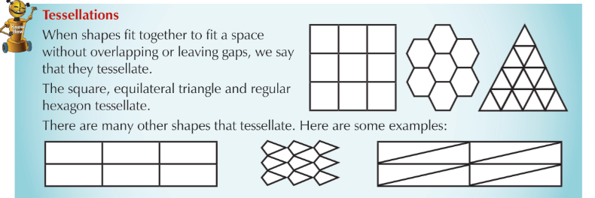
Can you complete the game on Nrich to make sure that there are no gaps between the spaces (you need Adobe Flash Player for this)? https://nrich.maths.org/814

- English Writing genre / Science:

- Here are all the time conjunction words used in this text – First, next, during this time, then, later, afterwards, finally, now. Did you find all of them?
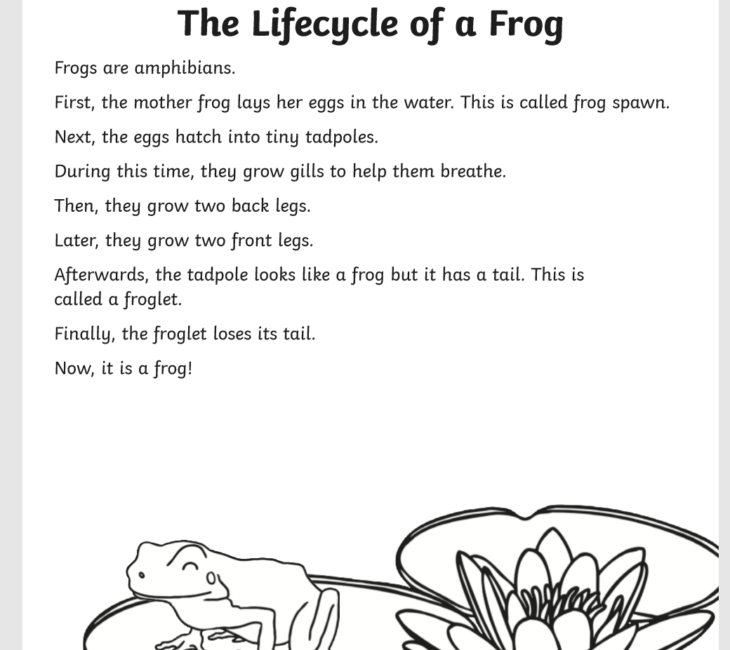

Explanation Texts Checklist | Yes / No?
- Is there a clear title to show what is being explained?  - An opening statement to introduce the process?  - Clear steps to show how or why something occurs?  - The events in order (what came first, second, third and so on)?  - Time conjunctions (e.g. before, after, then, next, finally, meanwhile)?  - Cause and effect conjunctions (e.g. because, so, this causes, therefore, thus, consequently, as a result)?  - Illustrations / diagrams / flow charts to make explanation clearer? | Yes  Yes  Yes  Yes  Yes  No  No

Day 4
- Mental Maths: Week 28 Thurs and Problem Solving
- Geography correcting: Correct these now where you did them in your copy. Here are the answers.

Day 4: Page 24 (1-5) answers
- Three lakes in Kerry are Lough Currane, Lough Caragh and the Lakes of Killarney.
- Two islands of the coast of Kerry are the Great Blasket Island and Valentia Island.
- Three towns in Kerry are Dingle, Tralee and Killarney. (Also Listowel, Castlemaine, Kenmare, Waterville and Cahirciveen)
- Two rivers in Kerry are R. Galey and R. Maine. (Also R. Laune, R. Inny)
- Co. Limerick and Co. Cork borders Co. Kerry.

Day 5: Page 27 (Q1-10) answers
- The 5 other counties in Munster are Cork, Limerick, Tipperary, Clare and Waterford.
- I think Kerry is called the Kingdom because a famous King used to live there long ago.
- County Kerry is located in the southwest of Ireland.
- County Limerick and County Cork border County Kerry.
- Three places you could visit in Kerry are Carrauntoohil, Killarney National Park and the Dingle Peninsula. (Also The Blasket Islands, Valentia, the Skelligs, the Ring of Kerry etc.)
- The climate in Kerry is milder than in other parts of Ireland due to the North Atlantic Gulf Stream.
- I think the weather on the Blasket Islands would be cold and windy as it is very exposed.
- I think no one lives on the Blasket Islands because it is very isolated from the rest of Ireland and people had to move away to find jobs.
- Kerry is similar to Dublin as Gaelic football is very popular in both counties.
- Kerry is different to Dublin as there are fewer people living in Kerry.

Day 6
Page 36 Puzzle Time answers.

uno = 1 due = 2 tre = 3 quattro=4 cinque=5 sei=6 sette=7 otto=8 nove=9 dieci=10

Day 7
Page 32 (questions at the bottom) answers
- In the north of Italy people are richer and because of this life is easier.
- In the south of Italy life is harder because it is poorer.
- I think the north is richer that the south because the north has better land, a better climate, a larger population and is closer to European markets so they can sell goods more easily.
- I would prefer to live in the north because life would probably be easier and more pleasant. I would probably get a job easier, I would like living closer to interesting cities like Milan and the weather wouldn’t be as hot as the south.

Page 33 (3 lines to answer at the bottom).
- Gnocchi (tiny shells of pasta)
- Fusilli (corkscrew-shaped pasta)
- Tagliatelle/Linguine (long strips of pasta)

If you’re interested in looking at all the different types of pasta, check this website out! https://www.nonnabox.com/types-of-pasta/ I never knew there were so many types!

Page 34 (all questions next to the square bullet points) answers.
- I will take the flight that departs Dublin at 15.25 because the other two are too early and would mean I’d have to get up in the middle of the night to catch them!
- My flight takes 3 hours and 5 mins.
- You lose an hour travelling to Italy from Ireland because Ireland is in a different time zone to Italy – it is one hour behind.

Check it out the different time zones around the world here! https://www.timeanddate.com/time/map/

- Silent reading: 30 minutes
- Tables: Spend 10 minutes on either www.multiplication.com or https://www.topmarks.co.uk/maths-games/7-11-years/multiplication-and-division. Work on the Division questions.
- Spelling: Continue with the next five words you found out you didn’t know, as described in Day 1.
- Irish: Go online to https://www.duolingo.com/learn Spend ten minutes or so on the exercises.

Maths Challenge (optional): 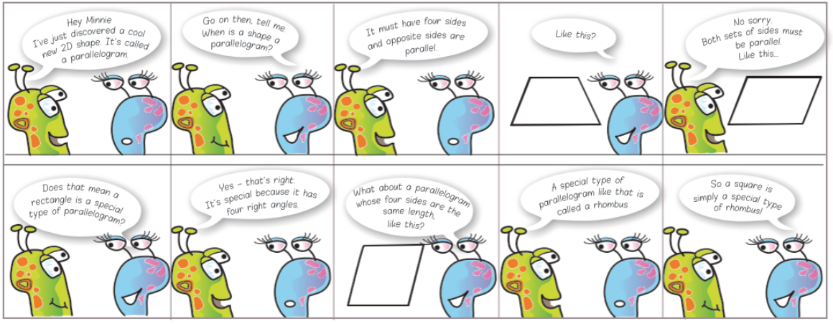
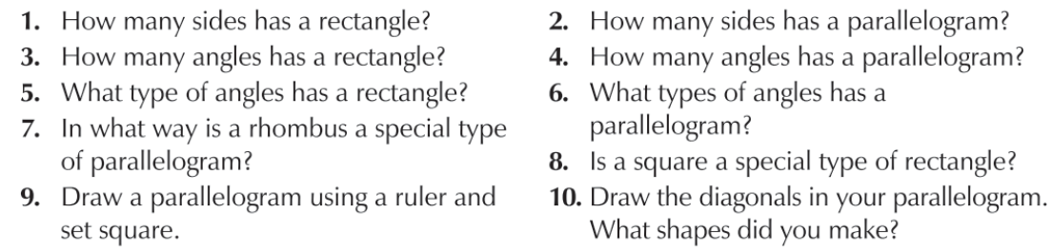

- English Writing genre / Science:

- Here are all the time conjunctions in this piece – after, in time, firstly, then, finally, during. Did you get them all?
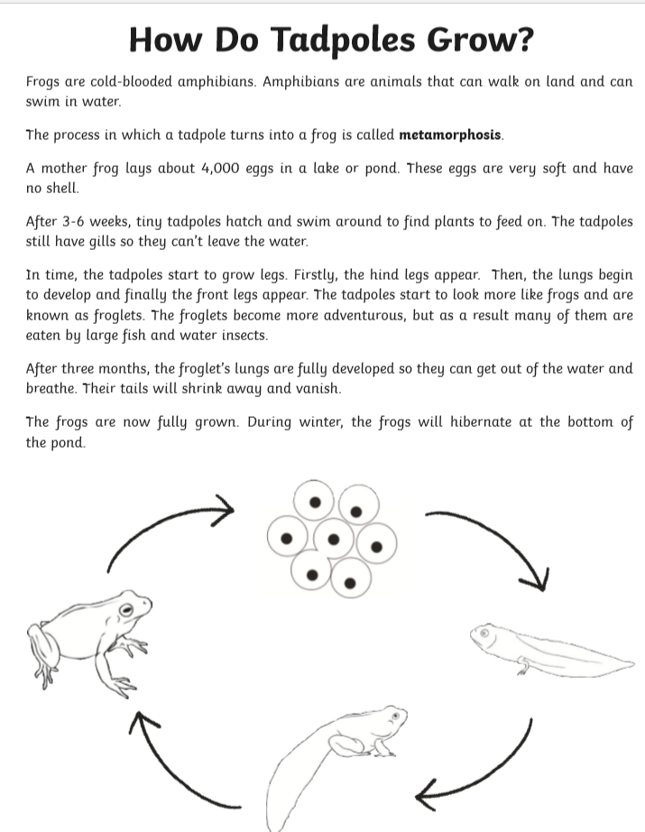
Explanation Texts Checklist | Yes / No?
- Is there a clear title to show what is being explained?  - An opening statement to introduce the process?  - Clear steps to show how or why something occurs?  - The events in order?  - Conjunctions of time (e.g. before, after)?  - Cause and effect conjunctions (e.g. because, so, this causes, therefore, thus, consequently, as a result)?  - Illustrations/diagrams/flow charts to make explanation clearer? | Yes  Yes  Yes  Yes  Yes  Yes

Day 5
- Mental Maths: Week 28 Fri review and Problem Solving
- Geography correcting: Correct these now where you did them in your copy. Here are the answers.

Day 8
- Page 35 (1 – 7) answers

- Italy is located in southern Europe.
- It has a mild Mediterranean climate.
- Three places I would like to visit in Italy are Rome, Milan and Venice.
- Here are five facts I learned about Italy:
- France, Switzerland and Austria border it.
- It is a very mountainous country with the Alps in the north and the Apennines in the centre.
- Rome is the capital city.
- The city of Florence is in Italy and is known for its art.
(Any other facts taken from page 31, you can mark as correct)
- Some Italian foods are pasta, olives, pizza and ciabatta bread.
- The differences between the north of Italy and the south are as follows. In the north, the people are richer. It is easier to sell goods to the rest of Europe because is it very close to those countries. There is a large population living there. The land is flatter which is good for farming and building factories. The good weather is suited to farming. However, in the south people are much poorer. There are few towns and most of the land is mountainous. The farms are small and far away from the European markets (countries that they could sell their produce to). It’s very hot and dry and they don’t get much rain in summer.
- Another country with a tricolor flag is Ireland!
Day 9
- Page 41 (1-8)

- The water cycle is the movement of water around the world. It is recycled over and over again.
- Evaporation is when water that is warmed by the sun turns into water vapour and rises.
- Condensation is when the water vapour cools and turns back into liquid, which then forms cloud droplets.
- Clouds are made of water vapour.
- Precipitation is when the water droplets become larger and heavier as more droplets stick to each other. They become heavy and fall to the ground as rain or snow.
- Pollution is when we dirty or add something that harms plant and animal life.
- Water can be polluted when factories release waste into rivers, when farmers’ sprays run into rivers and streams, when people dump rubbish into them and when oil tankers have oil spillages.
- We can help to prevent water pollution by not dumping rubbish into rivers, streams and the sea. We can write letters to newspapers and politicians asking them to make laws to stop factories and farmers polluting water. We can join organizations like Greenpeace and Friends of the Earth that work to look after the earth.

Day 10
- Page 41 Do Puzzle Time (1-4)

- Steam that rises is called vapour.
- Steam hitting a cold plate or mirror in a bathroom is an example of condensation.
- If you left a cup of water by the window and it disappeared, this is an example of evaporation.
- Another word for rain is precipitation.

SCIENCE INVESTIGATION answers
What I am trying to do: To create my own example of the water cycle
My prediction: The water in the cup will evaporate.
How I am going to carry out my investigation: I will half fill a cup with water and place it inside a ziplock freezer bag. I will seal it and place in the window where there is plenty of sunlight.
The result (what happened in the end?): Some water vapour called condensation was on the inside of the bag.
Analysis (why do I think this thing happened?): The sunlight heated the water vapour in the cup and made it evaporate. The water vapour hit the inside of the bag and cooled leaving condensation on it. Little trickles started to run back down – this is called precipitation.

A diagram would have a picture of a cup inside the bag and arrows pointing to where evaporation, condensation, precipitation and water vapour are.

- Silent reading: 30 minutes
- Tables: Spend 10 minutes on either www.multiplication.com or https://www.topmarks.co.uk/maths-games/7-11-years/multiplication-and-division. Work on the Division questions.
- Spelling: Continue with the next five words you found out you didn’t know, as described in Day 1.
- Irish: Go online to https://www.duolingo.com/learn Spend ten minutes or so on the exercises. Time to write down those 5 sentences you have picked and send them to me!
- Maths: 2D Shapes: Spend 10 minutes revising all you know about triangles and quadrilaterals - https://www.bbc.co.uk/bitesize/guides/zj76fg8/revision/1 .

Challenge Area - If you want a challenge...
Complete shape activity below - 'Medieval fun'.

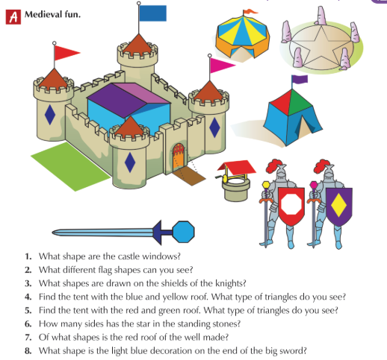
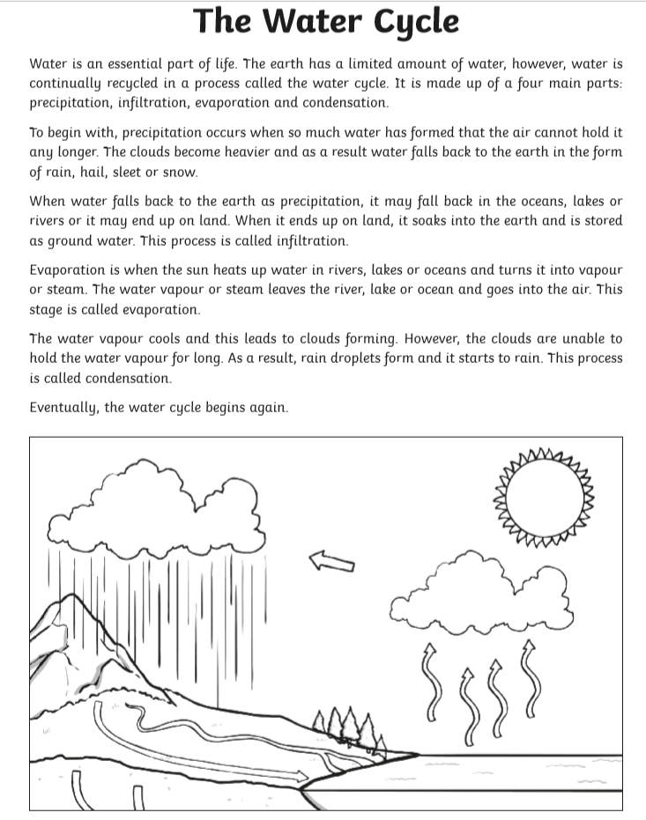
Explanation Texts Checklist  - Is there a clear title to show what is being explained?  - An opening statement to introduce the process?  - Clear steps to show how or why something occurs?  - The events in order?  - Conjunctions of time (e.g. before, after)?  - Cause and effect conjunctions (e.g. because, so, this causes, therefore, thus, consequently)?  - Illustrations/diagrams/flow charts to make explanation clearer? | Yes/No?  Yes  Yes  Yes  Yes  Yes  Yes  Yes

Have a nice week off and remember to wear sunscreen on sunny days!

