Ms Merry’s 4th Class 25/5/2020
Week 8

Hi all! Great to keep hearing from people through email. Try to correct your mental maths either as you go along each day or at the end of the week. If you are stuck on the problem-solving and can’t figure out where the answer came from, email me and I will try to explain. 😁 Try and have the sound turned on for the Creative Writing online exercises below.
Remember that the activities highlighted in red, is the work I want you to send me on the Friday of that week. Here is it for this week:
WORK TO SEND ON FRIDAY TO MY EMAIL
jmerry@scoilchaitrionasns.ie

- Your score for your spelling test that you will be doing on Friday from the list below.

- Five more sentences from Duolingo you will have learned this week.

- Your answers to the questions you will have done from your geography book.

Day 1
- Mental Maths corrections: Make sure you have corrected your work up as far as you have done.

https://www.newwavementalmaths.ie/my-login/

Log in: JMerry@scoilchaitrionasns.ie and the password is Mental1.

- Mental Maths: Week 30 Mon and Problem Solving

- Irish: Go online to https://www.duolingo.com/learn Spend ten minutes or so on the exercises.

- Spelling writing: These are your spellings for this week in the box below. Unjumble the word and write each one correctly.

If you don’t know what a word means, look up this online dictionary https://kids.wordsmyth.net/we/ (you put the word you are looking for in the box on the left-hand side).

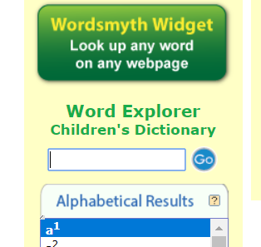

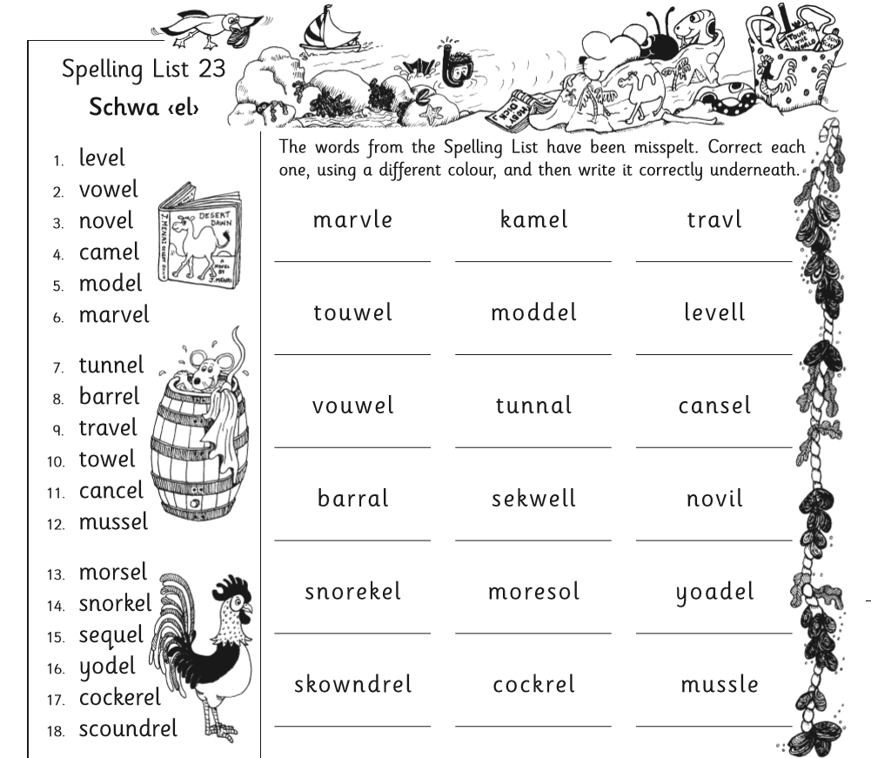
- Spelling learning: Look at the first 6 spellings – say the letters of each, picture in your head, write them and check your answer. Now write each one again, without looking and check if you know it.
- Creative Writing – Adjectives and adverbs:
Go to this website (it takes a good bit of time to upload). Add descriptive words to two simple sentences about a chef and a lady in a restaurant to make the sentences more interesting. Try all the different words in the different gaps and see how the pictures change!

http://www.scootle.edu.au/ec/viewing/L8742/index.html

Day 2
- Mental Maths: Week 30 Tue and Problem Solving
- Silent reading: 30 minutes
- Spelling: As above. Learn how to spell the next 6 spellings from the list above.
- Irish: Go online to https://www.duolingo.com/learn Spend ten minutes or so on the exercises.
- Creative Writing – adjectives and adverbs: Go to this link and download it.

http://www.scootle.edu.au/ec/viewing/L8741/index.html

Add descriptive words to two simple sentences about a boy and a girl at the beach to make the sentences more interesting. Try out different descriptive words in each sentence. Try all the different words in the different gaps and see how the pictures change!

- Geography Book: Read page 85 and 86. Write out the questions and answers in your copy as a ‘yes’ or ‘no’ from page 87.

Day 3
- Mental Maths: Week 30 Wed and Problem Solving
- Silent reading: 30 minutes
- Spelling: As above, next 6.
- Irish: Go online to https://www.duolingo.com/learn Spend ten minutes or so on the exercises.
- Creative Writing – adjectives and adverbs:

http://www.scootle.edu.au/ec/viewing/L8740/index.html

Add descriptive words to two simple sentences about a cat and a fish to make the sentences more interesting. Try all the different words in the different gaps and see how the pictures change!

- Geography Book: Read pages 88 and 89. Answer the questions on page 90 (Q’s 1 – 6) in your copy from ‘Question Time’.

Day 4
- Mental Maths: Week 30 Thurs and Problem Solving
- Spelling: Revise all the spellings you did this week by using look, cover, say the letters, write and check for the ones you found tricky.
- Silent reading: 30 minutes
- Irish: Go online to https://www.duolingo.com/learn Spend ten minutes or so on the exercises.
- Maths: Spend time on this page revising fractions.

https://ie.ixl.com/math/class-4/fractions-review

Day 5
- Mental Maths: Week 30 Fri review and Problem Solving
- Irish: Write down your 5 Irish sentences with the meanings for sending to me.
- Silent reading: 30 minutes
- Spelling: Ask someone at home to give you a test on these spellings. Good luck
- Maths: Watch this film on equivalent fractions in the fraction family of halves, quarters and eighths.

https://www.khanacademy.org/math/arithmetic/fraction-arithmetic/arith-review-visualizing-equiv-frac/v/equivalent-amount-of-pizza

Spend some time on this page. Keep going until you have got at least ten in a row correct!

https://ie.ixl.com/math/class-4/find-equivalent-fractions-using-area-models

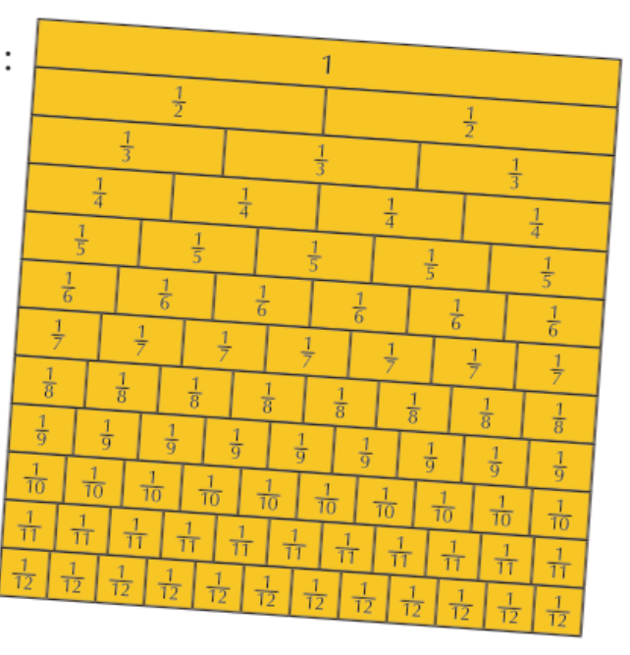

Maths answers from last week below
