Sixth Class Room 9 May 18th – 22nd
Hi all,
I know you’re all working really hard. I’m very impressed.
Thanks to the girls who sent lovely letters, messages and drawings to our Communion class. I know they must have been delighted.
I saw pictures of gorgeous home cooking on the website also. Well done. Many of you are extremely artistic. Use the website to display your work. Send pictures, recipes and so on to principal@scoilchaitrionasns.ie and Ms. Whelan will put your work online for us all to view.
For those of you who wish to practise your new language before September, download the app Duolingo. It’s a free learning aid. Lessons take about 15 minutes a day. It certainly is a very effective learning method.
Keep reading also. It doesn’t matter what you read. I’m so pleased to hear that many of you have read a great amount of books recently.
Below is a week’s work. Do your best to complete as much of it as possible.

- Spellings:
Page a week (as usual)
Please send your Friday test result to me.

- Mental Maths:
Test a day (Monday to Friday)
Correct your answers if you have access to the internet
https://www.newwavementalmaths.ie/my-login/
Email JMerry@scoilchaitrionasns.ie Password Mental1
6th Class : Practice
If you do not understand any of the questions, please email me and I will explain the answers. Remember to send your weekly score to me.

- Tables:
Multiplication: Spend 10 minutes daily on either of the following websites.
multiplication.com free click on Games and do multiplication and division games
topmarks.co.uk click on Times Tables
If you do not have access to the internet, learn the tables the usual way using a table book.

- Read at Home:
Read a page each day (Monday to Friday) Answer the questions orally. There’s no need to write the answers this week because you will be writing a story.

- Writing:
The task for this week is to write a narrative story. I’ve chosen the topics from a Junior Cert book. Choose one of the titles and write your narrative story.
- A Terrifying Experience
- The Wishing Chair
- The Mystery of the Golden Coin
Remember the outline of a narrative:
Orientation
Conflict / Complication
Resolution
- Title:
- Opening paragraph: Make the opening paragraph interesting and intriguing so we are curious and excited to read further.
Setting: Where?
- Characters: Add adjectives for clear descriptions.
- Plot: Conflict / Complications
- Resolution: The complications are resolved in your final paragraphs.
Monday:
Use your rough copy to form a plan.
In your rough copy write the opening paragraph. Include the setting and perhaps your main character.
Tuesday:
Continue with your story, adding other characters.
Ensure that your plot is clear and interesting. Don’t start with and, because, but or so! Check that you are using sufficient full stops!
Wednesday:
Finish your story, ensuring that you have a definite final paragraph.
Thursday:
Re-write half of your story in your English copy, on a new A4 sheet or type it.
Check for correct punctuation: Full stops, capitals, commas and so on.
Check for spelling errors.
Add interesting adjectives for descriptions.
Friday:
Complete re-writing your narrative.
I look forward to reading them.

- Scéal:
Instead of learning verbs this week, we’ll be revising scéalta in your folder. Try to learn two paragraphs a day (instead of one) and write them as we do. Score yourself. This learning will help you greatly in secondary.
Monday and Tuesday: Lá ag Siopadóireacht
Wednesday and Thursday: Ar an Trá
Friday: Mé Féin (first two paragraphs)

- Am don Léamh:
Scéal each week. Answer A-D
This week there’s no need to learn the abairtí because you’ll be learning the scéalta from your folder.
I have answers for the scéalta you have completed below. Please do any ceartúcháin necessary on your page in red pen.

- Duolingo:
Gaeilge: 10/15 minutes a day (If you have access to the internet)

- Read:
15 minutes or more daily (any books at home)

- Maths:
I have a revision sheet attached below for you to complete. Do 4 questions each day. Use your maths copy to answer them. Use your Maths Rules for help.
The answers of the previous fortnight’s questions are below also. Please correct your work and do corrections if you made any mistakes.

Am don Léamh: Freagraí
Rothar gan Solas: L. 23
- 1. Fíor 2. Bréagach 3. Bréagach 4. Bréagach 5. Bréagach 6. Bréagach
- 1. D’ordaigh siad píotsa.
2. Chuir siad DVD ar siúl.(on)
3. Chuaigh sí go dtí an siopa chun (to)bainne a fháil. (Téigh=to go: An ndeachaigh / chuaigh / ní dheachaigh)
4. Stop Garda Lára.
5. Chuir sé an rothar sa charr.
6. Cheannaigh sí cartán bainne / bainne.
- 1. píotsa 2. bainne 3. solas 4. DVD
- cnag, píotsa, dorcha (dark), solas
An Titanic: L. 25
- 1. Fíor 2. Bréagach 3. Fíor 4. Fíor 5. Fíor 6. Bréagach
- 1. Bhí dath dubh ar an Titanic / uirthi. / Dath dubh a bhí ar an Titanic / uirthi.
2. Bhí na ceoltóirí (musicians/singers) ag seinm ceoil./ Bhí siad ag seinm ceoil.
3. Bhuail (hit) an Titanic cnoc (mountain) oighir (ice).
4. Thosaigh uisce ag teacht isteach.
5. Thosaigh siad ag béiceadh (screaming) agus ag rith timpeall.
6. Léim siad isteach sna báid tarrthála. (rescue boats) / Léim siad isteach san fharraige.

- 1. An Titanic 2. Réaltaí (stars) 3. Cnoc oighir (iceberg) 4. Ag dul faoi (faoi=under, sinking)
- Long, ceoltóirí (singers/musicians), uisce, bás (Fuair siad bás=They died)

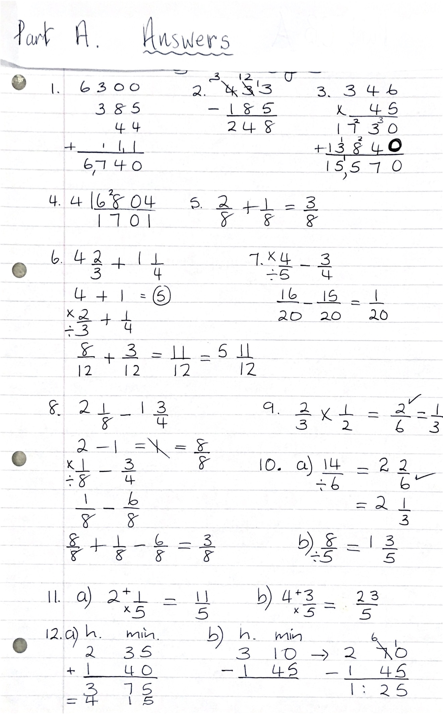
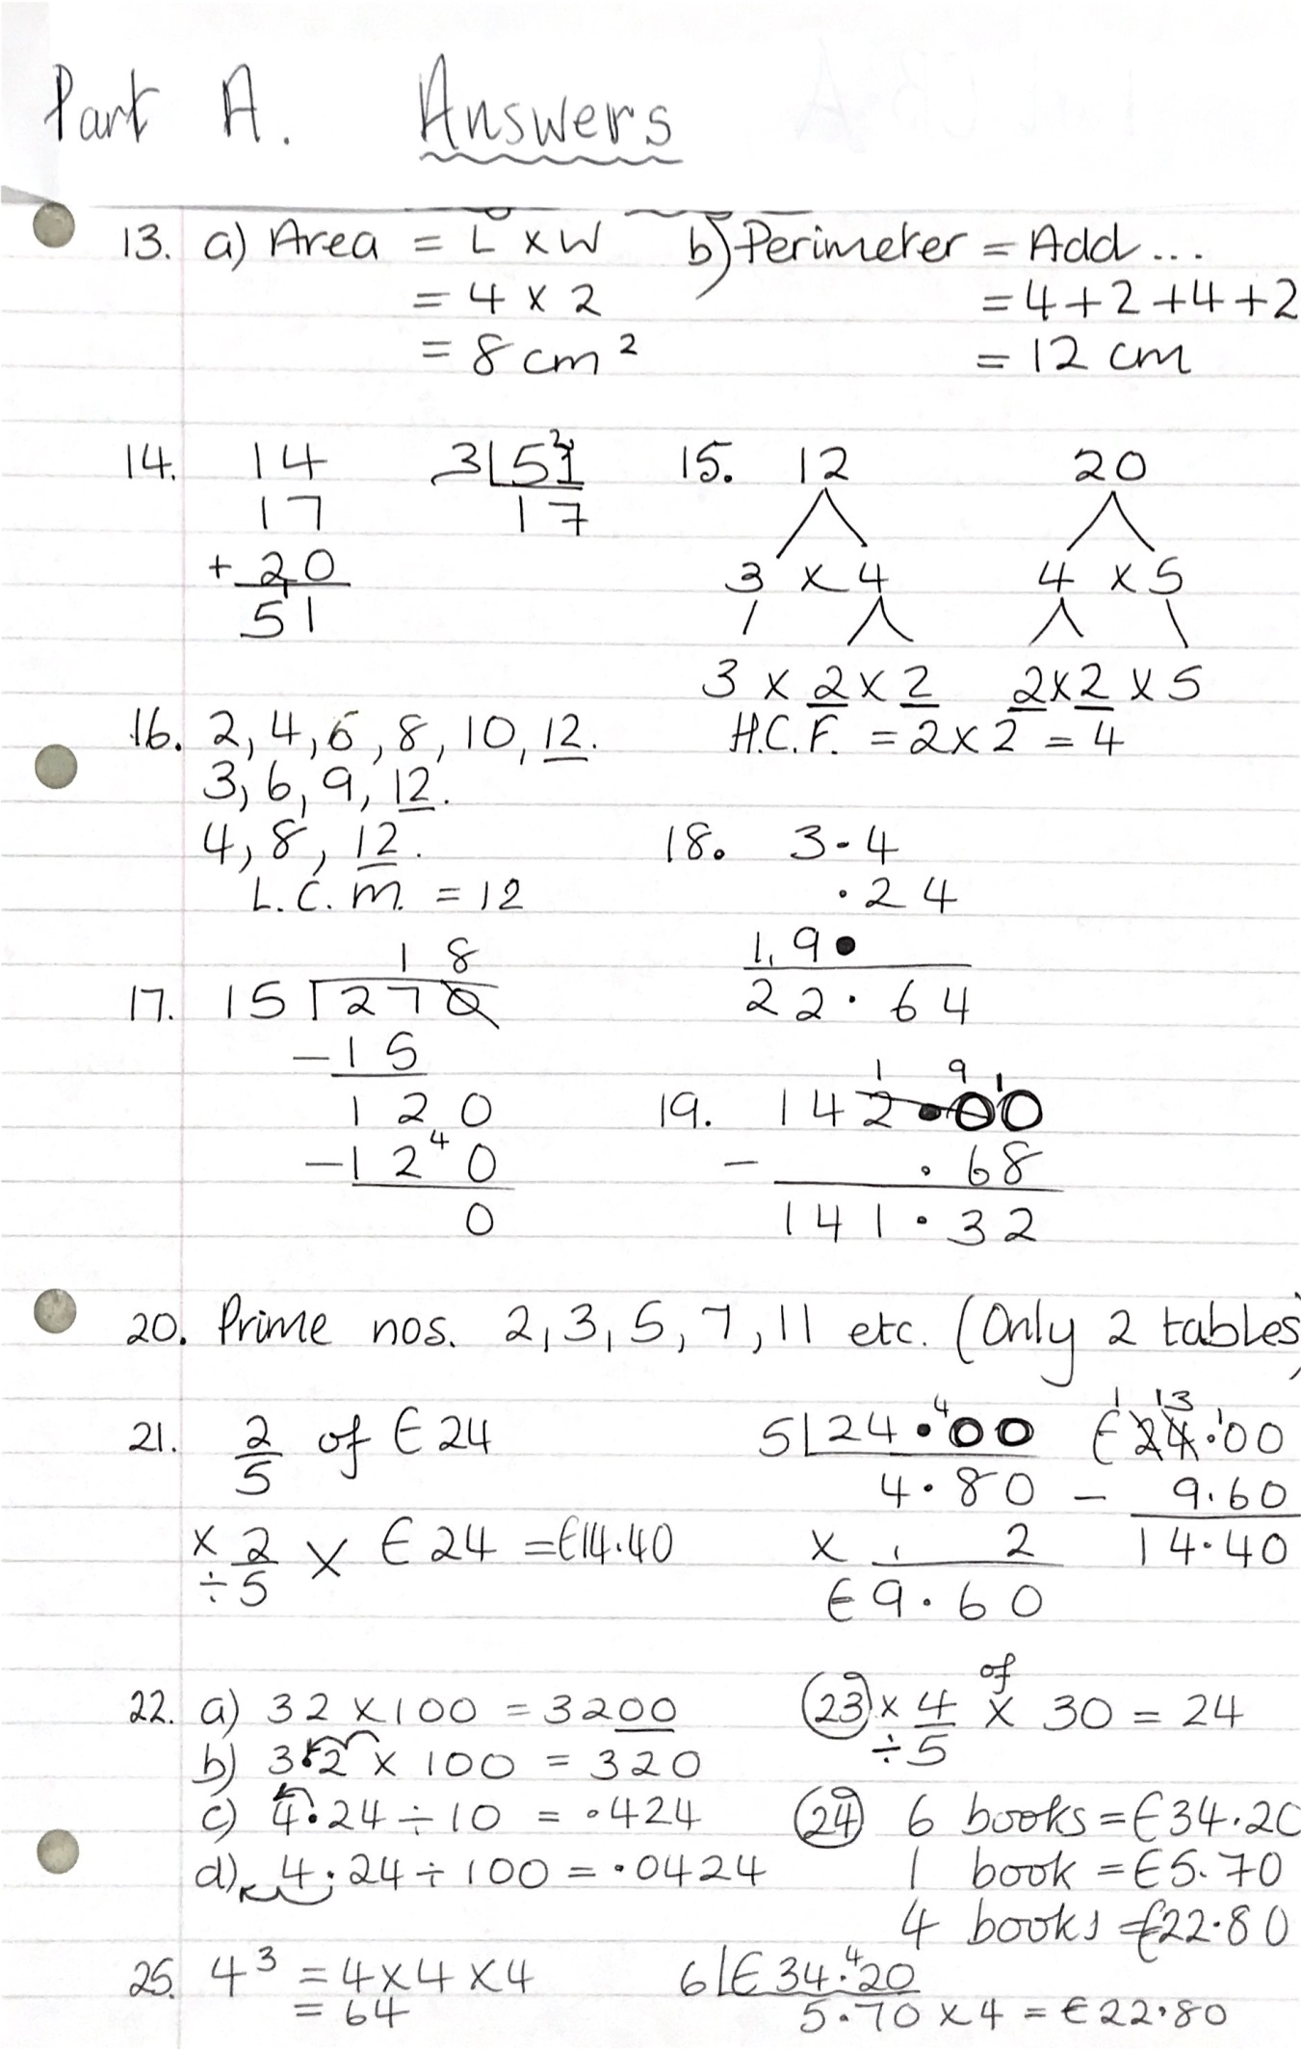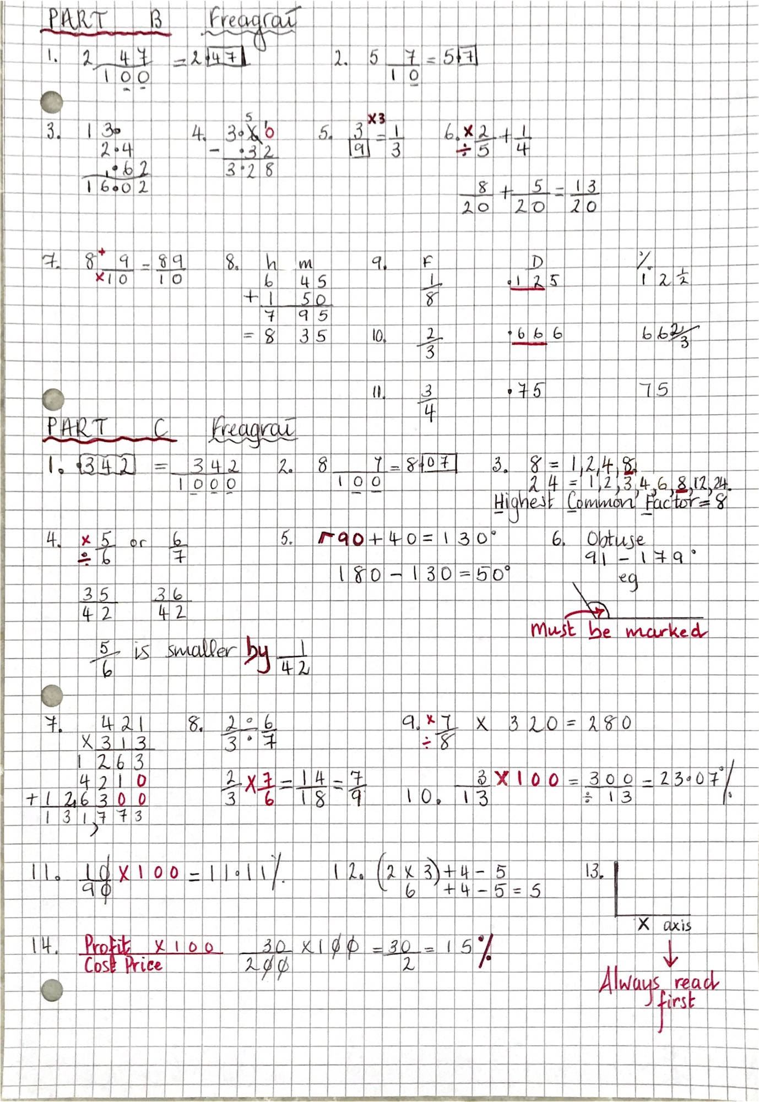

Maths for this week. Answer 4 questions a day.
