Hi girls,
Hope you and your families are keeping well and staying safe. Hope you have been outside enjoying the good weather. Below are some suggested activities that you can do at home over the next week. Looking forward to hearing from you. Please stay safe and mind yourselves.
Take care,
Ms. Conefrey

- PE
It is very important to stay active and here are some links to keep fit and active at home:
- Daily PE lesson with Joe Wicks - https://www.youtube.com/channel/UCAxW1XT0iEJo0TYlRfn6rYQ –
- Cosmic Kids Yoga - https://www.youtube.com/user/CosmicKidsYoga/featured
- Go noodle - https://www.gonoodle.com/

- Covid 19 Time Capsule
Please continue to work on this project. This is a link to a Covid-19 time capsule document –
https://s3.letsembark.ca/long-creations/2020-COVID-19-Time-Capsule-EN-US.pdf
If you want to email me pictures of it, I would love to see them.

- Mental Maths
Continue to work on mental maths. Try to do a mental maths test every day (Monday – Friday).
Please could you email me a photo of your weekly mental maths scores. If you do have any questions, queries or problems, please do email me and will try to help.

- Reading
Please continue to read every day for at least 15 minutes. Read the next story in My Read at Home Book 2 or read a book of your choice.

- Handwriting
Complete one page of handwriting a day.

- RTÉ Home School Hub
Watch RTÉ Home School Hub every day at 11am on RTÉ 2.

- Peace out Podcast – https://bedtime.fm/peaceout
The girls could listen to this podcast. It is a podcast with short stories to help children relax. They also have lovely videos on YouTube.

- Art – Learn to draw
Try to draw some of these:
https://artprojectsforkids.org/draw-a-fairytale-house/
https://artprojectsforkids.org/how-to-draw-a-dragonfly/
If you want to show me the picture that you drew, you can email me a photo. Remember to colour the picture in too!

- First Communion Prayers and Hymns – Please see sheets below. The girls could practice these at home.

- Gaeilge
- Watch cartoon as Gaeilge on https://www.cula4.com/ga/
- Practice your Gaeilge on https://www.duolingo.com/course/ga/en/Learn-Irish
- If your daughter has got their Fuaimeanna agus Focail in their folder, please continue working through it.

- Scavenger hunts - Do these scavenger hunts or make up your own one to do while you are at home or out walking.
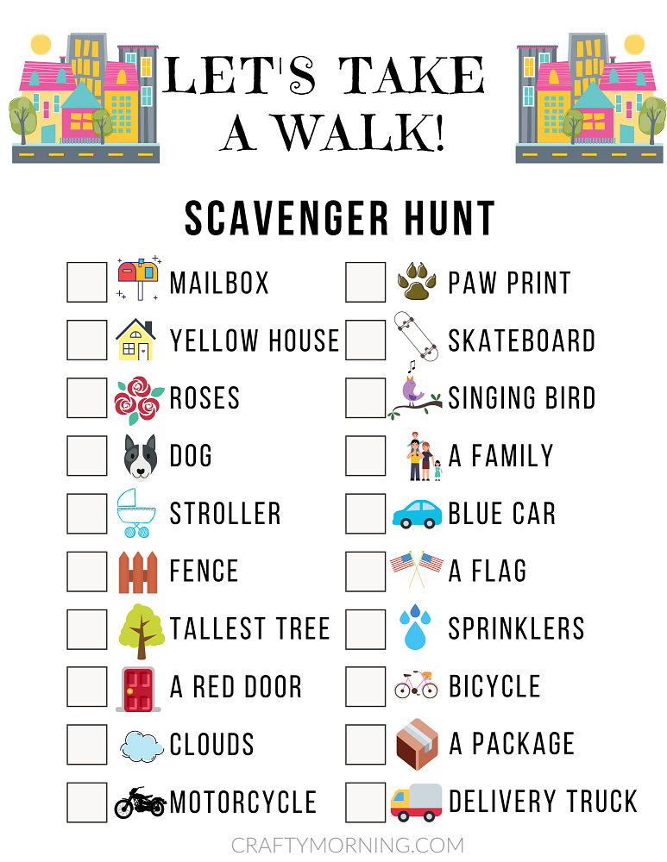

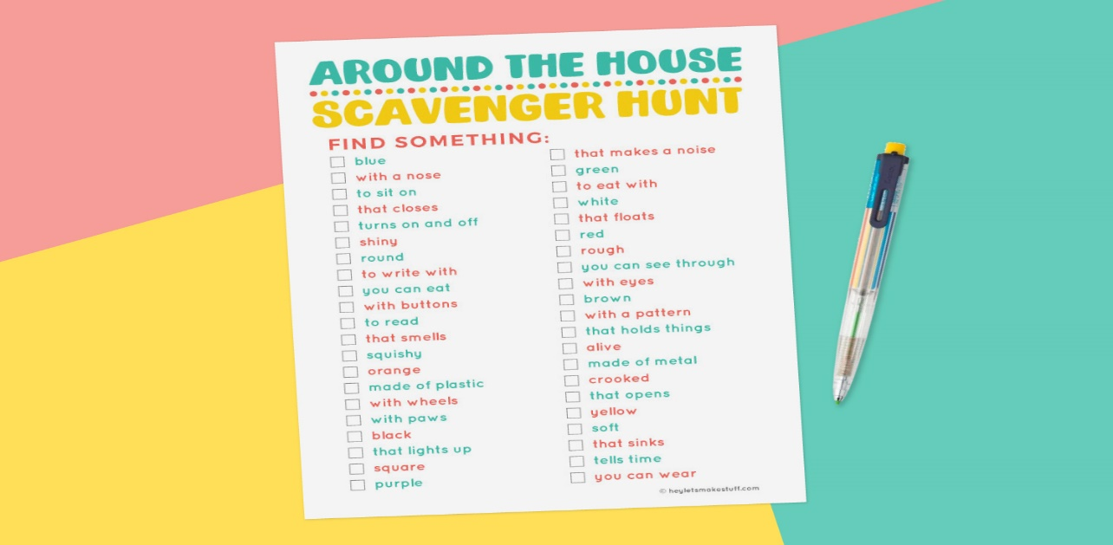

First Communion Prayers
Sanctus
Holy, Holy, Holy Lord God of hosts.
Heaven and earth are full of Your glory
Hosanna in the highest.
Blessed is he who comes in the name of the Lord
Hosanna in the highest.

Lamb of God
Lamb of God, you take away the sins of the world, have mercy on us
Lamb of God, you take away the sins of the world, have mercy on us
Lamb of God, you take away the sins of the world, grant us peace.

Invitation to Holy Communion
Lord, I am not worthy
that you should enter under my roof,
but only say the word
and my soul shall be healed.

Prayer before Communion
Lord Jesus, come to me.
Lord Jesus, give me your love.
Lord Jesus, come to me and give me yourself.

Lord Jesus, friend of children, come to me.
Lord Jesus, you are my Lord and my God.
Praise to you, Lord Jesus Christ.

Prayer After Communion
Lord Jesus, I love and adore you.
You’re a special friend to me.
Welcome, Lord Jesus, O welcome,
Thank you for coming to me.

Be near me, Lord Jesus, I ask you to stay
Close by me forever and love me, I pray.
Bless all of us children in your loving care
And bring us to heaven to live with you there.

I’m ready now, Lord Jesus.
To show how much I care.
I’m ready now to give your love
At home and everywhere
Hymns for the First Communion
Below are the lyrics and audio links on YouTube to the First Communion Hymns. The girls can listen and learn the words to the songs.

- Gathering Song - https://www.youtube.com/watch?v=uRxygR0D-us

GATHERING SONG
Come, let us gather before Him.
Come, let’s give thanks here today
Come, let us pray to the Father,
For He has shown us the way.

1. Jesus has called us by name.
Jesus has taught us to pray.
As friends we gather in His name.
With joy we sing and we say.

Come, let us gather before Him.
Come, let’s give thanks here today
Come, let us pray to the Father,
For He has shown us the way.

2. Let us sing praise to the Lord.
All who now gather to pray
Now celebrate the love of God
On this, the Lord’s special day

Come, let us gather before Him.
Come, let’s give thanks here today
Come, let us pray to the Father,
For He has shown us the way.

3. Jesus had very good friends
Who stayed with him all of the time
They followed Him wherever he went
And shared His bread and His wine

- The Lord, he is my shepherd - https://www.youtube.com/watch?v=XOpzj5c2YJs

THE LORD, HE IS MY SHEPHERD (PSALM 23)
The Lord, he is my shepherd
Nothing shall I need

1. The Lord, he is my shepherd
Nothing shall I need
He leads me to walk in green walk in green pastures.
He restores, restores my soul.

The Lord, he is my shepherd
Nothing shall I need

2. He keeps me on the right path
True to his name
He walks with me when I’m in darkness
And protects me from all harm.

The Lord, he is my shepherd
Nothing shall I need

3. His goodness and his kindness
Always follow me
And in my God’s house, I will live
For endless, endless days.

The Lord, he is my shepherd
Nothing shall I need

- We come to you, Lord Jesus - https://www.youtube.com/watch?v=7RGaHRfyCt4

WE COME TO YOU LORD JESUS
1. We come to you, Lord Jesus
To say our thanks to you
And in our Mass we bring ourselves
And ev’ry thing we do.

We love you Lord Jesus,
Stay with us we pray.
Help us to be more like you each day

2. We bring the bread, we bring the wine
We bring them now to you
We bring our work, we bring our play
And ev’ry thing we do

We love you Lord Jesus,
Stay with us we pray.
Help us to be more like you each day

3. Your love for us, our love for you
We celebrate today
Oh fill our hearts with peace and joy.
Be with us Lord, we pray.

We love you Lord Jesus,
Stay with us we pray.
Help us to be more like you each day

- Eat this bread - https://www.youtube.com/watch?v=BNtQijjIk6Y

EAT THIS BREAD
Eat this bread, drink this cup
Come to me and never be hungry
Eat this bread, drink this cup
Trust in me and you will not thirst

Anyone who eats this bread
Will live forever

- This is the Day - https://www.youtube.com/watch?v=zeTV3cpRUDo

THIS IS THE DAY
Sing! Sing! Sing alleluia.
This is the day the day Lord has made.
Dance! Dance! Dance alleluia.
This is the day the Lord has made.

1. Let us rejoice and be glad.
This is the day the Lord has made.
Let us rejoice and be glad.
This is the day.

Sing! Sing! Sing alleluia.
This is the day the day Lord has made.
Dance! Dance! Dance alleluia.
This is the day the Lord has made.

2. Play music to honour His name
This is the day the Lord has made
Sing psalms and songs of praise
This is the day.

Sing! Sing! Sing alleluia.
This is the day the day Lord has made.
Dance! Dance! Dance alleluia.
This is the day the Lord has made.

- Gifts from God – https://www.youtube.com/watch?v=7yfYj-8XrBc

GIFTS FROM GOD
1. We have been called to love the Lord, our God
We have been called to glorify his name
We have been called to love the Lord, our God
We have been called to glorify His name.

Use your skills, use your talents,
Use the gifts you have been given.
We’re all different, we’re all we’re all special in this world.
Use your skills, use your talents, use the gifts you have been given.
Give God glory, love all others, love our world.

2. We have been called to care for all our friends
We have been called to watch for everyone
We have been called to care for all our friends
We have been called to watch for everyone.

Use your skills, use your talents,
Use the gifts you have been given.
We’re all different, we’re all we’re all special in this world.
Use your skills, use your talents, use the gifts you have been given.
Give God glory, love all others, love our world.

3. We have been called to care for this, our world
We have been called to marvel at God’s work
We have been called to care for this, our world
We have been called to marvel at God’s work.

Use your skills, use your talents,
Use the gifts you have been given.
We’re all different, we’re all we’re all special in this world.
Use your skills, use your talents, use the gifts you have been given.
Give God glory, love all others, love our world.

